|  |
| --- |
| **Structural Technical Advisory Committee – 5 Comments** |
| **8th Edition (2023) Florida Building Code, Building**  **CHAPTER 16 STRUCTURAL DESIGN**  **1) S – B-Ch. 16 - Comment #1 [New Subject] (Page 2)**  **Angel Goitia**  **Comment on: Chapter 16 Structural Design Table 1607.1 MINIMUM UNIFORMLY DISTRIBUTED LIVE LOADS – Item #26.**  **TAC Recommendation: Deny 11-0**  **Commission Action:** |
| **2) S – B-Ch. 16 & R-Ch. 3 - Comment #2 (Page 3)**  **Eric Stafford – IBHS**  **Comment on: Figures 1609.3(1), 1609.3(2), 1609.3(3), and 1609.3(4) in the Florida Building Code, Building and Figure R301.2(4) in the Florida Building Code, Residential**  Or equivalent = Apply to building own wind speed data base  **TAC Recommendation: Approval 11-0**  **Commission Action:** |
| **CHAPTER 2 DEFINITIONS**  **CHAPTER 17 SPECIAL INSPECTIONS AND TESTS**  **3) S – B-Chs. 2/17 - Comment #1 (Page 7)**  **Joe Belcher – JDBCS - FHBA**  **Comment on Modifications (S10388) and (S10120)**  **202 Sun Control Structure**  **TAC Recommendation: Approval 11-0**  **Commission Action:**  **S10120-R1 - 1703.6.2.1 Concrete Testing Reports**  **TAC Recommendation: Approval 11-0**  **Commission Action:** |
| **8th Edition (2023) Florida Building Code, Test Protocols for High-Velocity Hurricane Zones**  **TESTING APPLICATION STANDARD (TAS) No. 110-2000**  **TESTING REQUIREMENTS FOR PHYSICAL PROPERTIES OF ROOF**  **MEMBRANES, INSULATION, COATINGS AND OTHER ROOFING COMPONENTS**  **4) R- TAS 110 - Comment #1 (Page 7)**  **Gaspar Rodriguez – Miami-Dade County**  **Comment on: 18. Referenced Standards**  **ASTM D8257-20 Standard Specification for Mechanically Attached Polymeric Roof Underlayment Used in Steep Slope Roofing**  **(R10146 AS)**  **TAC Recommendation: Approval 11-0**  **Commission Action:** |
| **8th Edition (2023) Florida Building Code, Test Protocols for High-Velocity Hurricane Zones**  **TESTING APPLICATION STANDARD (TAS) No. 100(A)-95**  **TEST PROCEDURE FOR WIND AND WIND DRIVEN RAIN RESISTANCE AND/OR INCREASED WINDSPEED RESISTANCE OF SOFFIT VENTILATION STRIP AND CONTINUOUS OR INTERMITTENT VENTILATION SYSTEM INSTALLED AT THE RIDGE AREA**  **5) R- TAS 100(A) - Comment #1 (Page 8)**  **Gaspar Rodriguez – Miami-Dade County**  **Comment on: TAS 100(A) MOD (R9907) - 5. Apparatus 5.1 The Test Frame 5.1.1**  **TAC Recommendation: Approval 11-0**  **Commission Action:** |

**Structural Technical Advisory Committee – Comments**

**8th Edition (2023) Florida Building Code, Building**

**CHAPTER 16 STRUCTURAL DESIGN**

**1) S – B-Ch. 16 - Comment #1 [New Subject]**

**From:** Angel Goitia [mailto:[angel.goitia@palmbeachschools.org](mailto:angel.goitia@palmbeachschools.org)]   
**Sent:** Tuesday, January 10, 2023 10:04 AM  
**To:** Madani, Mo <[Mo.Madani@myfloridalicense.com](mailto:Mo.Madani@myfloridalicense.com)>  
**Cc:** Mark Lodge <[mark.lodge@palmbeachschools.org](mailto:mark.lodge@palmbeachschools.org)>  
**Subject:** Recommendation for Item Inclusion in FBC 8th Edition Draft

Chapter 16 Structural Design

Table 1607.1 MINIMUM UNIFORMLY DISTRIBUTED LIVE LOADS...

Item 26. Roofs -should read as follows;

              All other construction, except one- and two-family dwellings  30 UNIFORM (psf)

              Ordinary flat, pitched, and curved roofs (that are not occupiable) 30 UNIFORM (psf)

This recommendation is to have the roof live load design be more in line with the maximum allowable water to be potentially collected on a roof 5" (5.2 lbs, the weight of 12" x 12" x 1" of water x 5" is 26 lbs, thus rounded to 30 lbs/psf), as applicable in the hvhz.

Regards, 

Angel Goitia, RA

Building Plans Examiner, Building Code Services

Division of Support Operations

Exceeding Expectations

School District of Palm Beach County

3661 Interstate Park Road North, Suite 200

Riviera Beach, FL  33404

|  |  |  |
| --- | --- | --- |
| 26. Roofs  All roof surfaces subject to main- tenance workers  Awnings and canopies:  Fabric construction supported by a skeleton structure  All other construction, except one- and two-family dwellings  Ordinary flat, pitched, and curved roofs (that are not occupiable)  Primary roof members exposed to a work floor  Single panel point of lower chord of roof trusses or any point along primary structural members supporting roofs over manufac- turing, storage warehouses, and repair garages  All other primary roof members Occupiable roofs:  Roof gardens Assembly areas  All other similar areas |  | 300 |
| 5m |  |
| ~~20~~ 30 |  |
| ~~20~~ 30 |  |
|  | 2,000  300 |
| 100  100m  Note 1 | Note 1 |

**2) S – B-Ch. 16 & R-Ch. 3 - Comment #2**

**From:** testafford@charter.net [mailto:testafford@charter.net]   
**Sent:** Monday, January 30, 2023 1:33 PM  
**To:** Madani, Mo <Mo.Madani@myfloridalicense.com>  
**Cc:** 'Shabanian, Milad' <mshabanian@ibhs.org>  
**Subject:** Comment on the 8th Edition (2023) Florida Building Code, Building and Florida Building Code, Residential

Mo…Please accept the following comments/changes to the 8th Edition (2023) Florida Building Code -

**Add the following new note to Figures 1609.3(1), 1609.3(2), 1609.3(3), and 1609.3(4) in the Florida Building Code, Building:**

6.  Location-specific wind speeds shall be permitted to be determined using the ASCE Wind Design Geodatabase.  The ASCE Wind Design Geodatabase can be accessed at the ASCE 7 Hazard Tool (<https://asce7hazardtool.online>) or equivalent.

**Add the following new note to Figure R301.2(4) in the Florida Building Code, Residential:**

8.  Location-specific wind speeds shall be permitted to be determined using the ASCE Wind Design Geodatabase.  The ASCE Wind Design Geodatabase can be accessed at the ASCE 7 Hazard Tool (<https://asce7hazardtool.online>) or equivalent.

**Rationale:**  This note provides consistency with the wind speed map notes and Section 26.5.1 in ASCE 7-22.  When the wind speed maps were updated for the 8th Edition (2023) FBC, we overlooked an important note the was added to the maps in ASCE 7-22.  Many jurisdictions and engineers across Florida have been relying on the ATC Hazard by Location wind speed database for site-specific wind speeds.  The ATC wind speed database provides site-specific wind speeds for ASCE 7-16 and earlier versions.  However, ATC does not plan to update the database to include wind speeds for ASCE 7-22.  The wind loading provisions in the 8th Edition (2023) Florida Building Code have been updated to ASCE 7-22.   The ASCE Wind Design Geodatabase (also referred to as the ASCE 7 Hazard Tool) provides key site-specific design parameters in ASCE 7 including wind speeds for ASCE 7-10, ASCE 7-16, and ASCE 7-22.  The ASCE Wind Design Geodatabase is a free tool that is maintained by ASCE.  Since ATC will not be updating their database to ASCE 7-22, it is important to add this note for users of the FBC to ensure site-specific winds comply with the 8th Edition (2023) Florida Building Code.

See the following from ASCE 7-22:

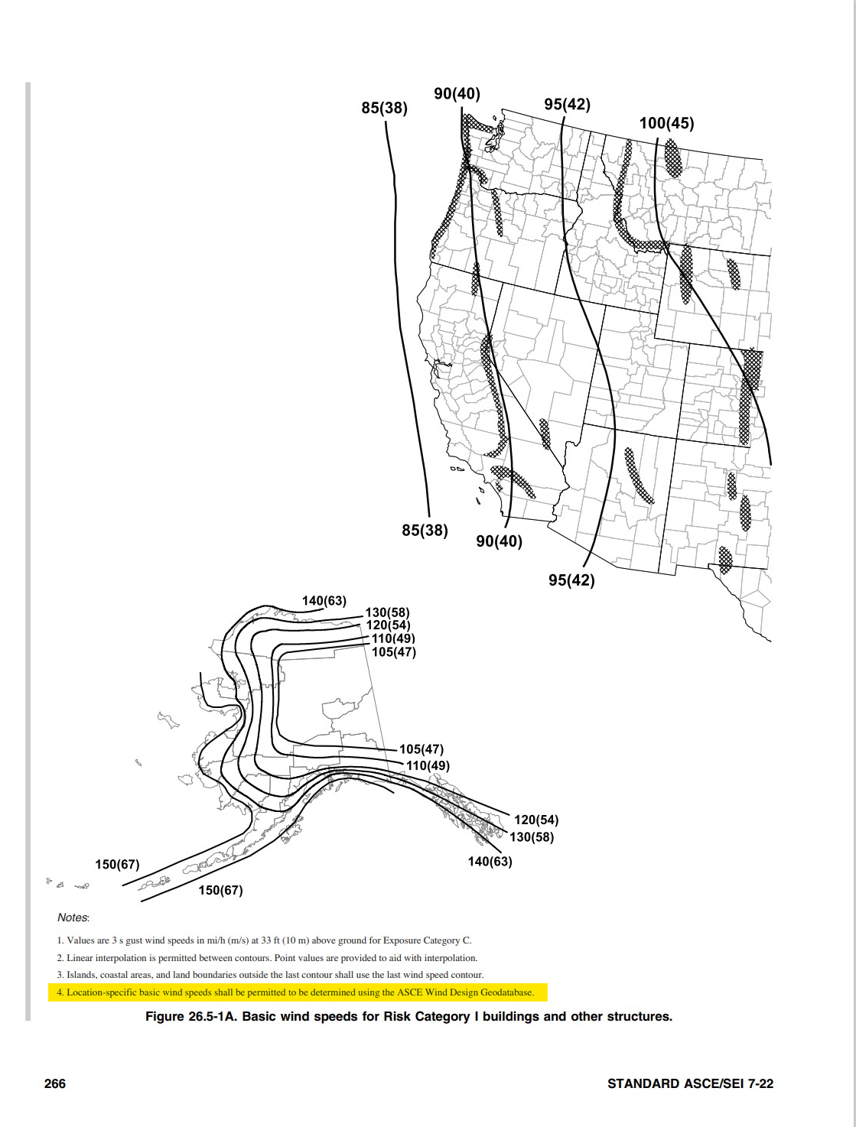

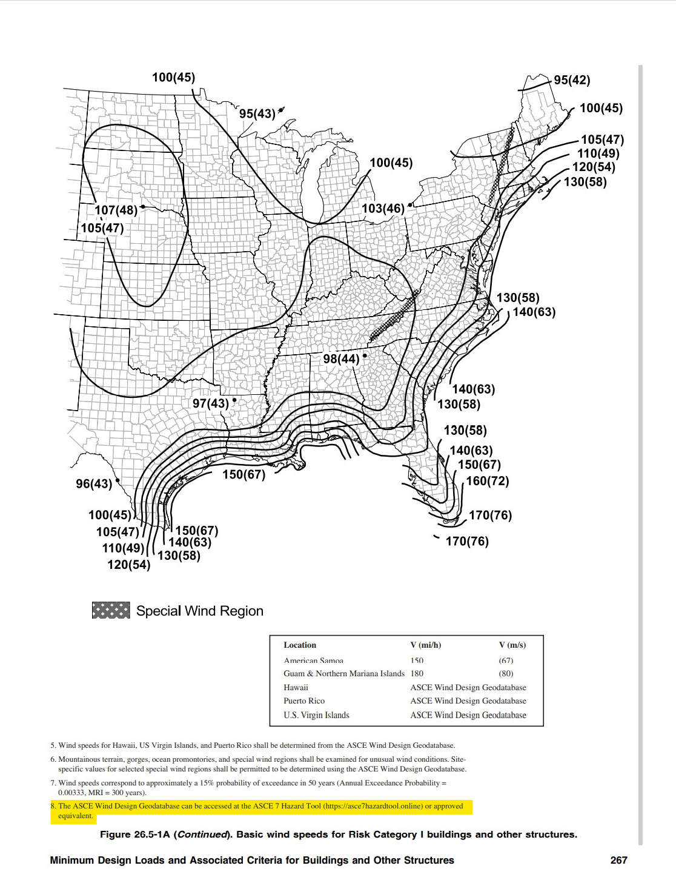

**CHAPTER 2 DEFINITIONS**

**CHAPTER 17 SPECIAL INSPECTIONS AND TESTS**

**3) S – B-Chs. 2/17 - Comment #1**

**To: Mo Madani, DBPR**

**From: Joe Belcher, JDBCS**

**Date: January 25, 2023**

**Re: Alternate Language Mods S10388 and S10120**

Mr. Madani,

Please accept the following as alternate language to the Mods.

**S10388-R1**

**Accessory Structure – No Change.**

**202 Sun Control Structure.**An ~~independently supported~~ accessory structure consisting of columns or posts supporting an open roof of girders, beams, or cross rafters with or without fixed or operational louvers serving to direct sunlight. ~~Sun Control Structures attached to and depending on a building for support are considered the same occupancy class as the supporting building.~~

**RATIONALE:** Structural TAC members requested the changes in the Florida Building Code-Building and Residential. I neglected to make the changes in the Florida Building Code-Building. The change to the Florida Building Code-Residential was approved. Approval of this change will bring the two volumes into agreement. The alternate language proposed is to make the correction.

**S10120-R1**

**1703.6.2.1 Concrete Testing Reports.**Where this code, a referenced standard, a building official or inspection agency requires testing of concrete on a project, test reports shall be provided to the building official or inspection agency, the registered design professional of record, and the material supplier concurrent ~~with~~ when reporting results to the client.

**RATIONALE:** The change is to correct a grammatical error.

**8th Edition (2023) Florida Building Code, Test Protocols for High-Velocity Hurricane Zones**

**TESTING APPLICATION STANDARD (TAS) No. 110-2000**

**TESTING REQUIREMENTS FOR PHYSICAL PROPERTIES OF ROOF**

**MEMBRANES, INSULATION, COATINGS AND OTHER ROOFING COMPONENTS**

**4) R- TAS 110 - Comment #1**

**From:** Rodriguez, Gaspar (RER) [mailto:Gaspar.Rodriguez@miamidade.gov]   
**Sent:** Monday, January 30, 2023 2:34 PM  
**To:** Madani, Mo <Mo.Madani@myfloridalicense.com>  
**Cc:** Gascon, Jaime (RER) <Jaime.Gascon@miamidade.gov>  
**Subject:** FBC MOD R10146

The following is a comment under the Public Comments provision for the 2023 Code Cycle.

This comment is strictly regarding the misspelled word, Mechanically.

If you have any questions, please contact me.

**18. Referenced Standards**

ASTM D8257-20 Standard Specification for **Mechanically** Attached Polymeric Roof Underlayment

Used in Steep Slope Roofing

**(R10146 AS)**

**TESTING APPLICATION STANDARD (TAS) No. 100(A)-95**

**TEST PROCEDURE FOR WIND AND WIND DRIVEN RAIN**

**RESISTANCE AND/OR INCREASED WINDSPEED RESISTANCE OF**

**SOFFIT VENTILATION STRIP AND CONTINUOUS OR INTERMITTENT**

**VENTILATION SYSTEM INSTALLED AT THE RIDGE AREA**

**5) R- TAS 100(A) - Comment #1**

**From:** Rodriguez, Gaspar (RER) [mailto:Gaspar.Rodriguez@miamidade.gov]   
**Sent:** Monday, January 30, 2023 2:33 PM  
**To:** Madani, Mo <Mo.Madani@myfloridalicense.com>  
**Cc:** Gascon, Jaime (RER) <Jaime.Gascon@miamidade.gov>  
**Subject:** TAS 100(A) MOD R9907

Hello Mo,

The following are comments under the Public Comments provision for the 2023 Code Cycle.

These comments are truly editorial, and I believe self-explanatory.

**5. Apparatus**

5.1 The Test Frame

5.1.1 The test frame shall consist of a base structure of sufficient dimensions to hold the test specimen noted in Section 8, constructed from wood or steel framing, and a wood deck, constructed from plywood sheathing. ~~Deck support joists shall be placed at 24 in. centers. (See Figure 1.)~~ ~~The deck slopes, on the windward and leeward side, shall be adjustable or multiple interchangeable decks shall be available to test assemblies at slopes of 2 in., 4 in. and 6 in. in 12 in.~~The deck support assembly shall be capable of supporting not less than 55 lbs per square foot of dead load. The windward end and each side of the test frame shall be covered with plywood to ~~insure~~ ensure soffit to ridge airflow.

8.1.4 A tray or other means of collecting water shall be installed on the underside of the ridge and/or deck area to capture any water which infiltrates the ridge area ventilation system. The tray or other means shall be sized and configured to ~~insure~~ ensure that all water penetrating the ridge area ventilation system or the ventilation unit, is captured.

**(R9907)**