FLORIDA BUILDING COMMISSION

GREEN BUILDING FORUM
REPORT TO THE FLORIDA BUILDING COMMISSION

October 1, 2007

Tampa, Florida

Meeting Design & Facilitation By

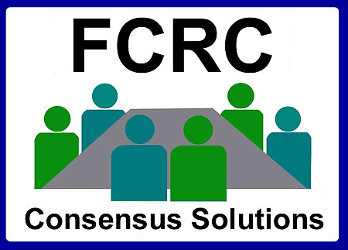

Report By Jeff A. Blair
Florida Conflict Resolution Consortium
Florida State University

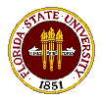

jblair@fsu.edu
http:// consensus.fsu.edu

This document is available in alternate formats upon request to Dept. of Community Affairs, Codes & Standards, 2555 Shumard Oak Blvd., Tallahassee, FL 32399, (850) 487-1824.
FLORIDA BUILDING COMMISSION

GREEN BUILDING FORUM REPORT
October 1, 2007

OVERVIEW

The Green Building Workgroup will work with FSEC to develop recommendations for a model efficiency ordinance for residential development. FSEC will provide additional research and support by identifying and soliciting input from local governments and other organizations with current and developing initiatives for energy conservation, green building and
sustainable development, including but not limited to, energy and water conservation and
hurricane resistant buildings and communities.

The Green Building Workgroup will work with FSEC to develop recommendations for
developing and implementing a public awareness campaign that promotes energy efficiency and the benefits of building green and implement the components deemed feasible within the funds
available through this contract. The public awareness campaign shall include website, trade
show, print media and television strategies. FSEC will provide additional research and support by identifying strategies for using print advertising, press releases, and television advertising to promote voluntary utilization of energy efficiency and green building practices and to present recommendations to the Commission at the December 2007 meeting for approval. The campaign shall focus on the benefits of promoting energy efficiency to the purchasers of new homes, the various green building ratings and labels available, and the promotion of various energy-efficient products through existing trade shows.

DCA Staff Present
Rick Dixon, Ila Jones, Mo Madani, Ann Stanton, and Betty Stevens.

Meeting Facilitation
The meeting was facilitated by Jeff Blair and Hal Beardall from the Florida Conflict Resolution Consortium at Florida State University. Information at: http://consensus.fsu.edu/

Project Webpage
Information on the project, including agenda packets, meeting reports, and related documents may be found in downloadable formats at the project webpage below:
http://consensus.fsu.edu/FBC/GBW.html

Meeting Objectives
The following objectives were reviewed:

- To Review Forum Participation Ground-Rules.
- To Hear an Overview of Green Building Workgroup’s Scope and Charge.
- To Hear Relevant Presentations.
- To Solicit Input on Key Issues and Options Regarding Recommendations for Developing a Model Efficiency Ordinance for Residential Development.
- To Solicit Input on Key Issues and Options Regarding Recommendations for a Public Awareness Campaign that Promotes Energy Efficiency and the Benefits of Building Green.
- To Review Next Steps and Project Delivery Schedule.

Review of Public Input Forum and Green Building Workgroup Scope

Rick Dixon reviewed the scope for the Forum and Workgroup and answered questions.

(See overview section of this report)

Florida Green Building Coalition Overview

Mike Houston, president of the Florida Green Building Coalition provided the Forum participants with an overview of the Florida Green Building Coalition’s programs.

Water Conservation—Florida Water Star Program Overview—Saint Johns River WMD

Linda Burnette, director of the Saint Johns Water Management District’s Office of Communications and Governmental Affairs, provided the Forum participants with an overview of the Florida Water Star Program.

Model Green Building Ordinance—Sarasota County Green Building Ordinance Overview

Paul Radauskas, Sarasota County Building Official, provided the Forum participants with an overview of the Sarasota County Green Building Ordinance.

Existing Web-Based Resources Overview—Florida Solar Energy Center

Sherri Shields, Florida Solar Energy Center’s Assistant Director of Information and Publication Services, provided the Forum participants with an overview of some of the existing web-based resources regarding Green Building and energy conservation.

Disaster Resistant Homes Overview—My Safe Florida Home

Tim Reinhold, Director of Engineering for the Institute of Business and Home Safety, provided the Forum participants with an overview disaster resistant homes.

Issues and Options for Model Ordinance Input to Workgroup

Members of the public were invited to provide their perspectives on the issues, options, and resources they felt the Green Building Workgroup should evaluate regarding recommendations for developing a model efficiency ordinance for residential development.
Issues and Options for Public Awareness Campaign Input to Workgroup
Members of the public were invited to provide their perspectives on the issues, options, and resources they felt the Green Building Workgroup should evaluate regarding recommendations for a public awareness campaign that promotes energy efficiency and the benefits of building green.

Overview of Green Building Workgroup Delivery and Meeting Schedule
Jeff Blair reviewed the Workgroup process and meeting schedule with participants.
Following is the schedule:

Meeting Schedule
Meeting I October 1, 2007 Tampa
Meeting II October 31, 2007 Gainesville
Meeting III November 28, 2007 West Palm Beach

