Exova Warringtonfire North America T: 905-822-4111
2395 Speakman Drive F: 905-823-1446
Mississauga, Ontario info@exova.com
Canada www.exova.com
L5K 1B3



ASTM E 84 – Surface Burning Characteristics of Materials

Test Description:  The Steiner Tunnel, designated herein as ASTM E 84, "Standard Method of Test for Surface Burning Characteristics of Building Materials", is designed to determine the relative surface burning characteristics of materials under specific test conditions. Results are expressed in terms of Flame Spread Index (FSI) and Smoke Developed (SD).  The tunnel is pre-heated to a specified temperature and allowed to cool to a pre-test temperature. The tunnel lid is raised and the test sample is placed along the ledges of the tunnel so as to form a continuous ceiling 24 feet long, 12 inches above the floor. The lid is then lowered and the ignition burners are ignited at one end of the specimen. The flame spread distance is observed and recorded every 15 seconds and calculations are made to determine FSI and SD, based on comparison data with red oak. |  | 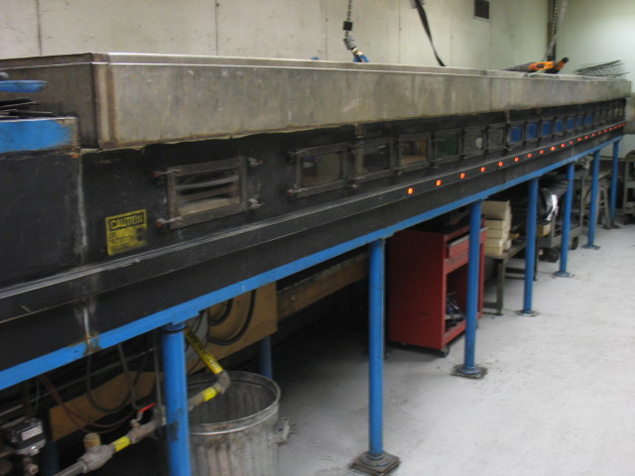

Sample Requirements:

Sample Size: 21 inches (533 mm) x 24 feet (7315 mm) (i.e. 3 pieces, each 21 inches (533 mm) x 8 feet (2438 mm))

Number of Specimens Required: 1

Additional Considerations:
Specimen Mounting: If a substrate is required (fiberglass reinforced cement board or gypsum board), then additional sample preparation fees would apply.
Specimen Thickness: Specimens thicker than 3 inches (75 mm) require tunnel lid modification. Additional fees would apply.

Application: Steiner Tunnel – Ceiling Mounting

American Building Code requirements for building materials, primarily for ceiling and wall material applications

Typical Classifications: Class A or 1 (FSI = 0 to 25), Class B or 2 (FSI = 26 to 75), Class C or 3 (FSI = 76 to 200)
All classifications specify a maximum Smoke Developed (SD) of 450

Comparable Test Procedures: UL 723, NFPA 255, CAN/ULC-S102, CAN/ULS-S102.2

Accreditation: To ISO/IEC 17025 for a defined Scope of Testing by the International Accreditation Service (IAS)

