Product Approval Enhancement Screen Shots

- Currently, Testing Laboratories are one Entity Type that can also register as a Validation Entity in BCIS. Remove this functionality. This would not retroactively affect Product Approval applications. DCA will deactivate any Testing Laboratories that are currently approved Validation Entities so they are no longer able to be selected in the application process.
Estimate: 48 hours * $75/hour = $3,600

Submit/Edit an Organization Application
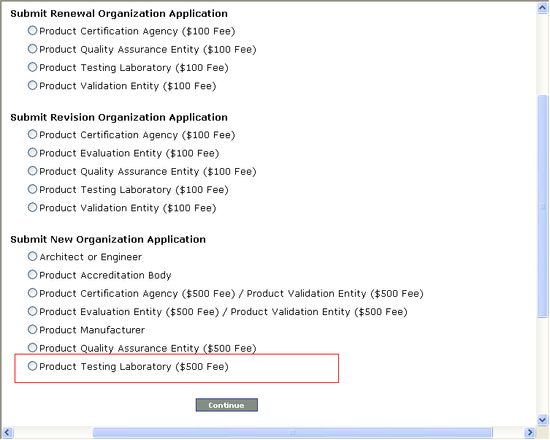

- Reorder the Code Compliance Methods on Page 1 of the Product Application to match the order shown in the Rule.
Estimate: 10 hours * $75/hour = $750

Submit a Product Application > Page 1
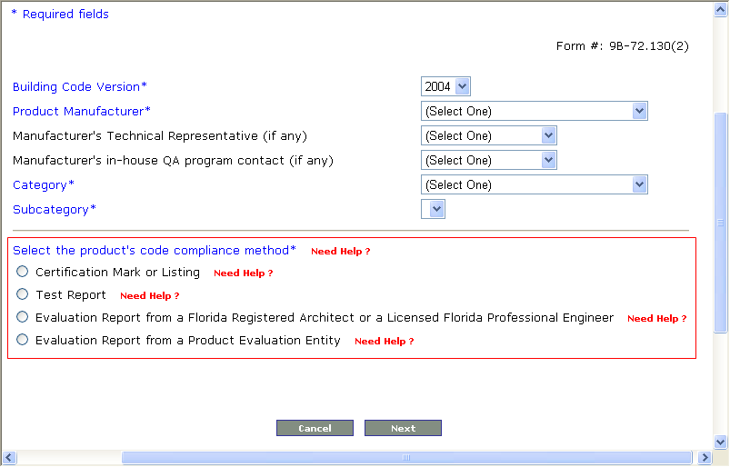

- Add a Validation Checklist for the Certification Mark or Listing Code Compliance Method, which will then make all Methods go through the Validation process on BCIS.
Estimate: 80 hours * $75/hour = $6,000

Submit a Product Application > Page 2, Certification Mark or Listing Method
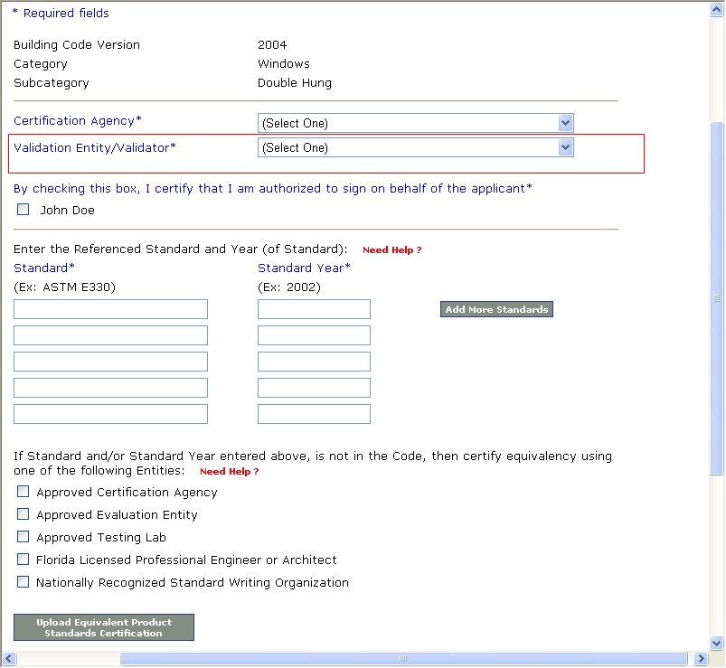

Please see Administrative and Technical Validation Checklists, Certification Mark or Listing Method screen shots below in #8.

- For all Code Compliance Methods, except the Certification Mark or Listing Method, add a field to collect the Expiration Date of the Quality Assurance Entity Contract on Page 2 of the application. Send an email to the Manufacturer and copy DCA when the Expiration Date has passed. Allow for searching where the Quality Assurance Entity Contract has expired. Also give the Administrator the ability to update the Quality Assurance Entity Contract Expiration Date.
Estimate: 60 hours * $75/hour = $4,500

  - Test Report Method

Submit a Product Application > Page 2, Test Report Method
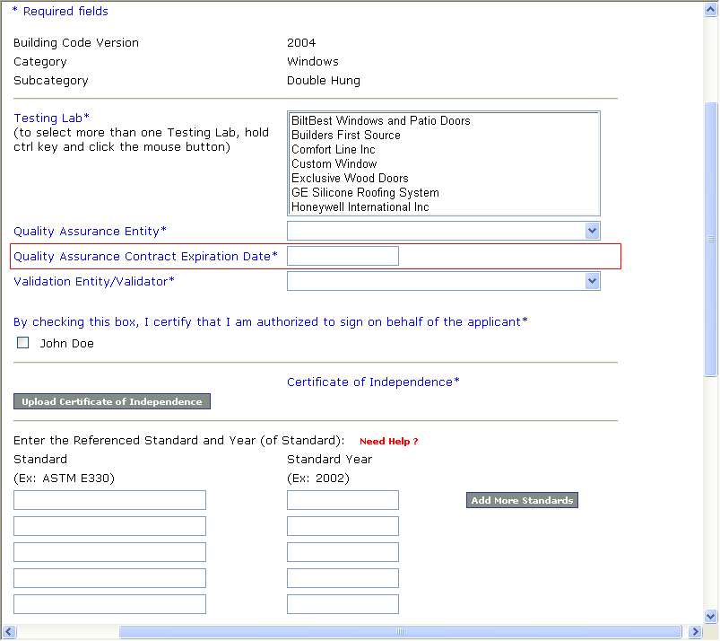
Submit a Product Application > Page 2, Test Report Method (continued)
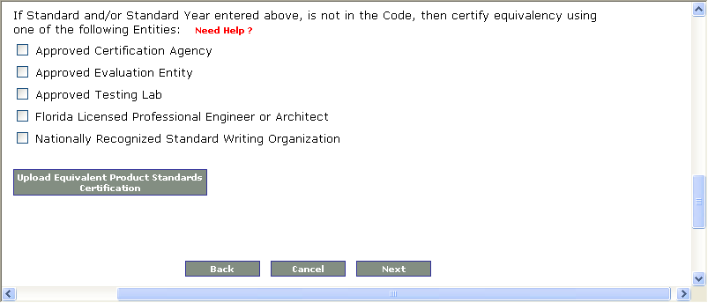

  - Evaluation Report from a Florida Registered Architect or a Licensed Florida Professional Engineer Method

Submit a Product Application > Page 2, Evaluation Report from a Florida Registered Architect or a Licensed Florida Professional Engineer Method
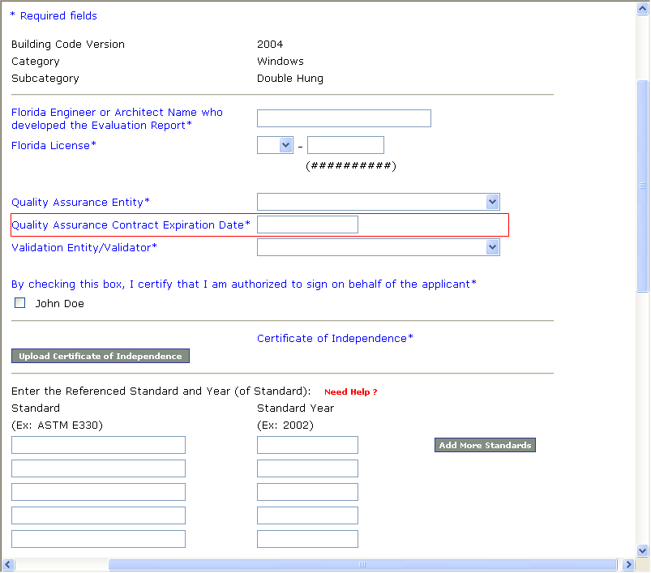

Submit a Product Application > Page 2, Evaluation Report from a Florida Registered Architect or a Licensed Florida Professional Engineer Method (continued)
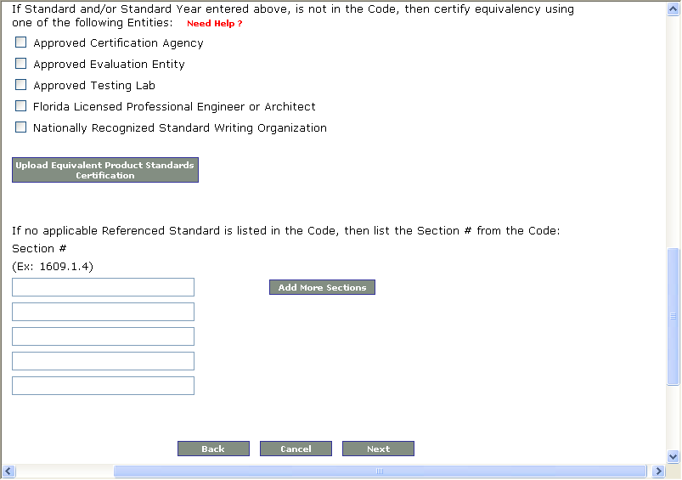

  - Evaluation Report from a Product Evaluation Entity Method

- For Evaluation reports issued by an “Approved” Evaluation Entity, other than Architect or Engineer, the Certificate of Independence is not required for each application. Make the “Certificate of Independence” file attachment optional on only the Evaluation Report by an Evaluation Entity Method.
Estimate: 24 hours * $75/hour = $1,800

Submit a Product Application > Page 2, Evaluation Report from a Product Evaluation Entity Method
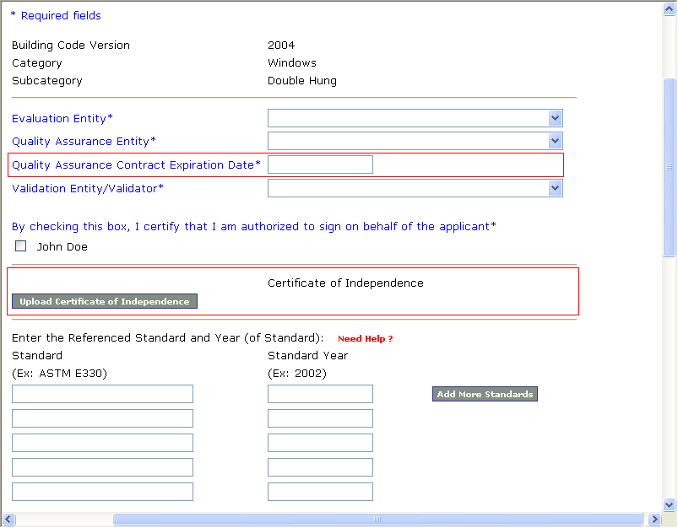
Submit a Product Application > Page 2, Evaluation Report from a Product Evaluation Entity Method (continued)
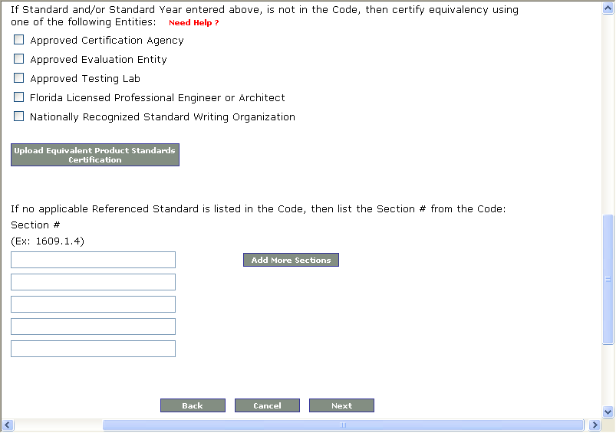

Administrator Application Detail
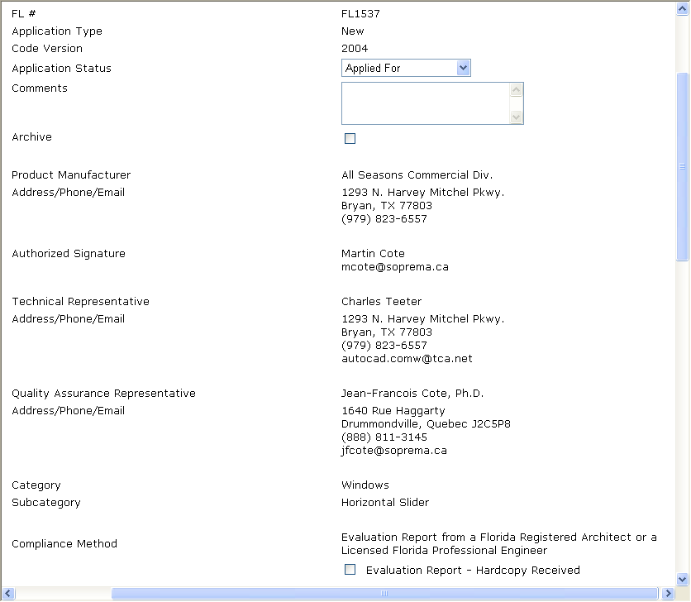

Administrator Application Detail (continued)
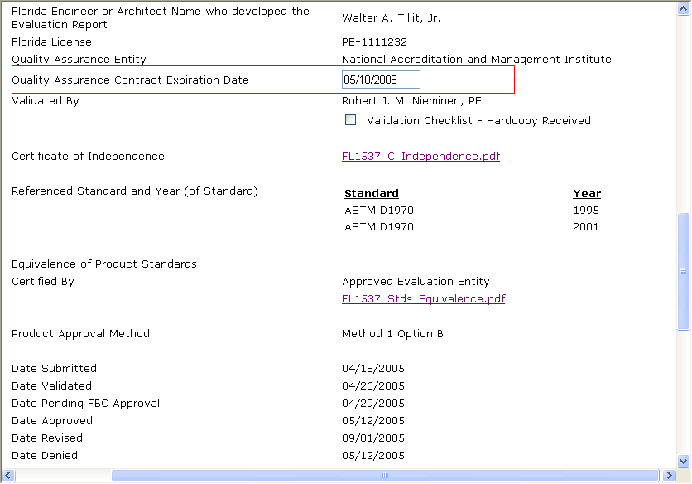
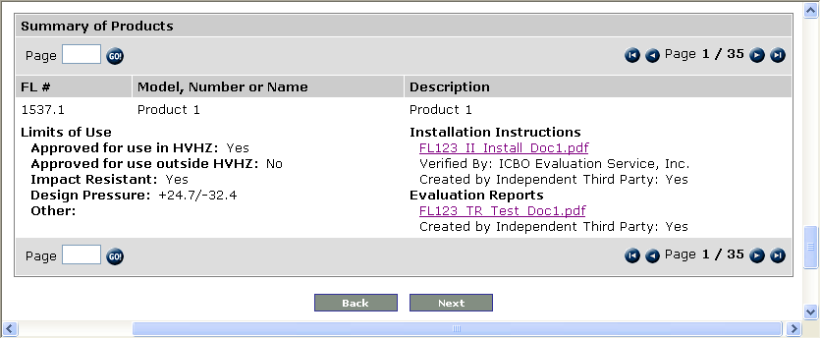

- For the Certification Mark or Listing Code Compliance Method, add a field to collect the Expiration Date of the Quality Assurance Entity Contract on Page 3 of the application. Send an email to the Manufacturer and copy DCA when the Expiration Date has passed. Allow for searching where the Quality Assurance Entity Contract has expired.
Estimate: 40 hours * $75/hour = $3,000

- In the Certification Mark or Listing Method, products using Rational Analysis must demonstrate compliance using an Evaluation Report.
  - On Page 3 of a Certification Mark or Listing Method application, ask if Rational Analysis was used with a checkbox first, and if the user checks that field, trigger a required upload of an Evaluation Report at the Product level. The upload is only permitted if the Rational Analysis checkbox has been checked.
Estimate: 52 hours * $75/hour = $3,900

- Administrative vs. Technical Validation
Estimate: 72 hours * $75/hour = $5,400
  - Based on the logic shown below to determine if Administrative or Technical Validation is required on each Code Compliance Method, add text to the emails sent to the Validator specifying which type of Validation is required and for Technical Validation, if it is required on the Installation Instructions, Evaluation Reports, or both.
  - Also designate on the Technical Validation checklists whether the Installation Instructions, Evaluation Reports, or both are required to be Technically Validated.
  - For the Certification Mark or Listing Method
    - If “verification” of the Installation Instructions was done by the Certification Agency, there is no need to ask if an Independent Third Party created the Installation Instructions, and Administrative Validation must be done.
    - Only if the “verification” of the Installation Instructions was not done by the Certification Agency, ask the following:
      - On Page 3 of the Product Application, ask “Installation Instructions created by an Independent Third Party” with Yes or No answer options.
        - If the answer is Yes, Administrative Validation must be done.
        - If the answer is No, Technical Validation must be done and the following 3 checkboxes must be shown on the Validation Checklist:
          - Determination that the evaluator has complied with acceptable standards of engineering principles.
          - Engineering verification that the evaluation complies with the Code.
          - Copy of the application complying with all aspects of rule 61G15-36 F.A.C., must be filed with the Commission.
    - If an Evaluation Report has been uploaded (see #7 above), ask “Evaluation Reports created by an Independent Third Party” with Yes or No answer options.
      - If the answer is Yes, Administrative Validation must be done.
      - If the answer is No, Technical Validation must be done and the following 3 checkboxes must be shown on the appropriate Validation Checklist:
        - Determination that the evaluator has complied with acceptable standards of engineering principles.
        - Engineering verification that the evaluation complies with the Code.
        - Copy of the application complying with all aspects of rule 61G15-36 F.A.C., must be filed with the Commission.

Submit a Product Application > Page 3, Certification Mark or Listing Method
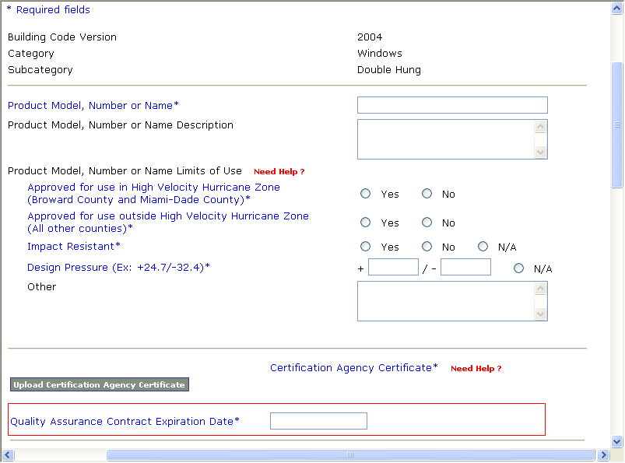

Submit a Product Application > Page 3, Certification Mark or Listing Method (continued)
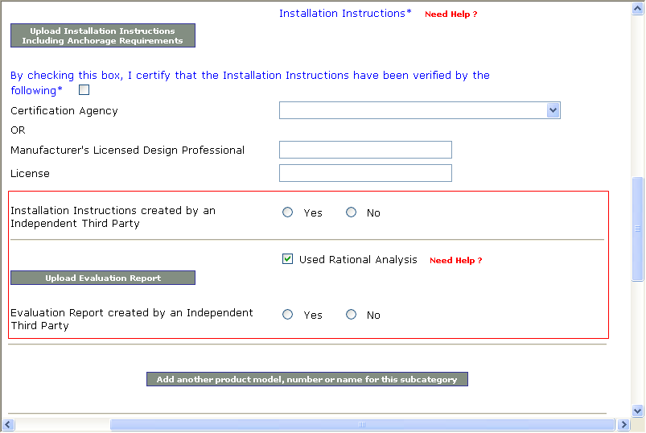
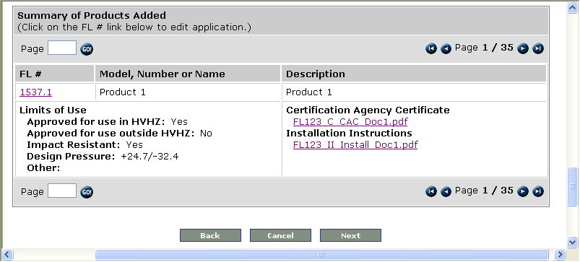

Administrative Validation Checklist, Certification Mark or Listing Method
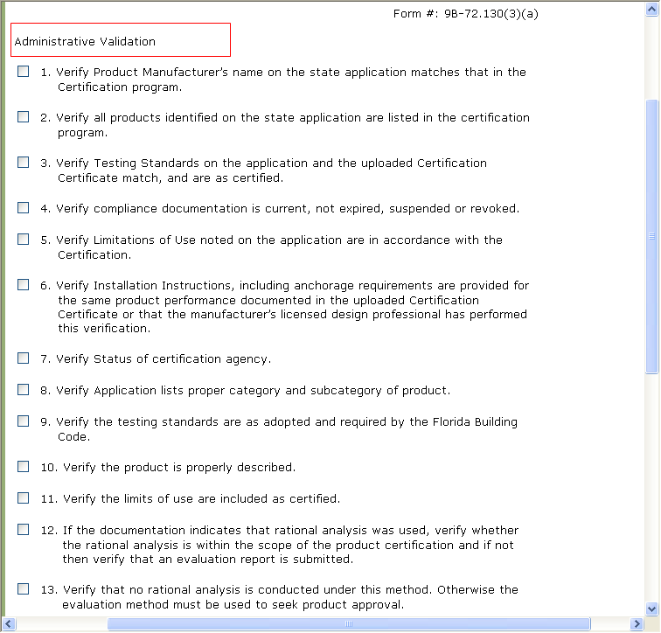
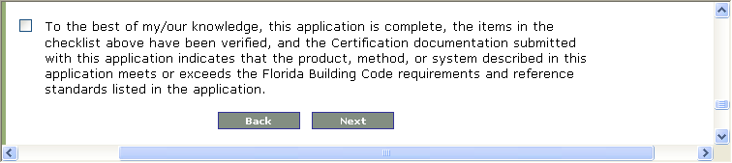
Technical Validation Checklist, Certification Mark or Listing Method
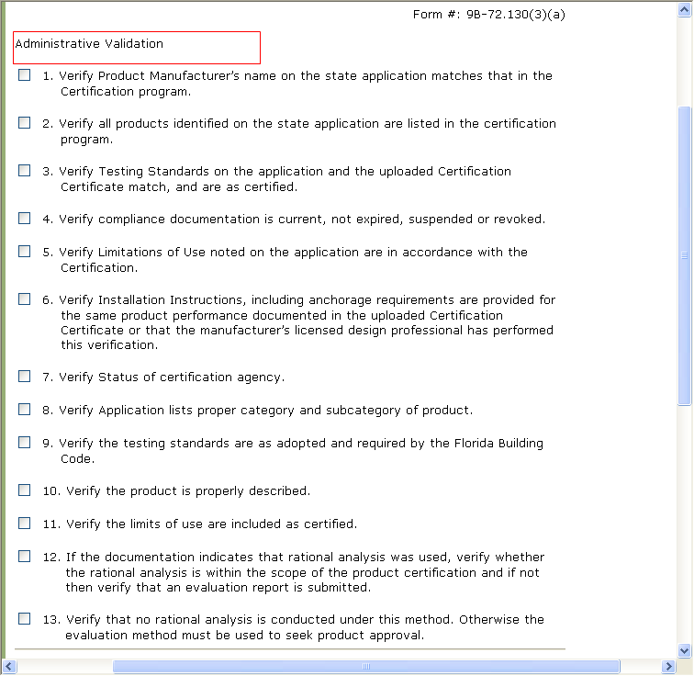
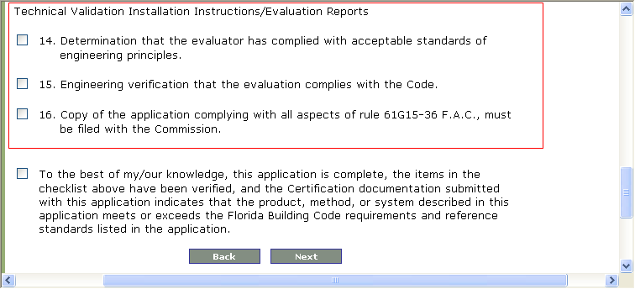
  - For the Evaluation Report from a Florida Registered Architect or a Licensed Florida Professional Engineer Method
    - If “verification” of the Installation Instructions was done by the Evaluation Entity, there is no need to ask if an Independent Third Party created the Installation Instructions, and Administrative Validation must be done.
    - Only if the “verification” of the Installation Instructions was not done by the Evaluation Entity, ask the following:
      - On Page 3 of the Product Application, ask “Installation Instructions created by an Independent Third Party” with Yes or No answer options.
        - If the answer is Yes, Administrative Validation must be done.
        - If the answer is No, Technical Validation must be done and the following 3 checkboxes must be shown on the appropriate Validation Checklist:
          - Determination that the evaluator has complied with acceptable standards of engineering principles.
          - Engineering verification that the evaluation complies with the Code.
          - Copy of the application complying with all aspects of rule 61G15-36 F.A.C., must be filed with the Commission.
    - On Page 3 of the Product Application, ask “Evaluation Reports created by an Independent Third Party” with Yes or No answer options.
      - If the answer is Yes, Administrative Validation must be done.
      - If the answer is No, Technical Validation must be done and the following 3 checkboxes must be shown on the appropriate Validation Checklist:
        - Determination that the evaluator has complied with acceptable standards of engineering principles.
        - Engineering verification that the evaluation complies with the Code.
        - Copy of the application complying with all aspects of rule 61G15-36 F.A.C., must be filed with the Commission.

Submit a Product Application > Page 3, Evaluation Report from a Florida Registered Architect or a Licensed Florida Professional Engineer Method
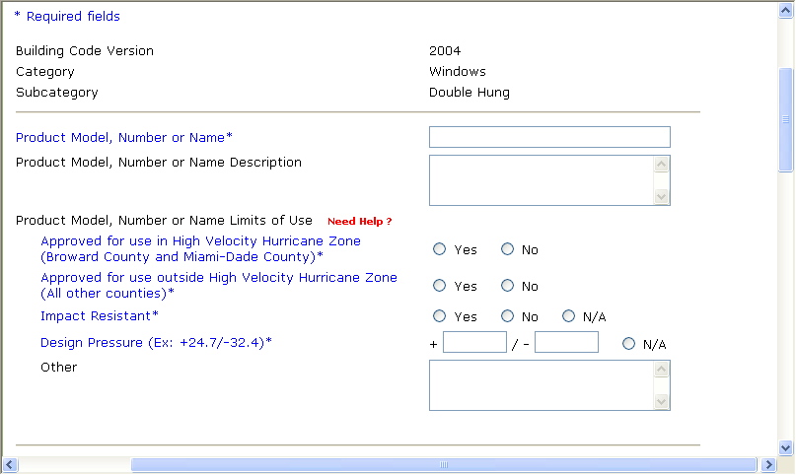
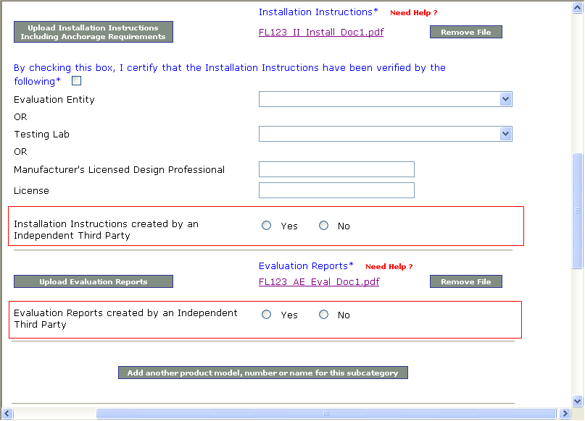

Submit a Product Application > Page 3, Evaluation Report from a Florida Registered Architect or a Licensed Florida Professional Engineer Method (continued)
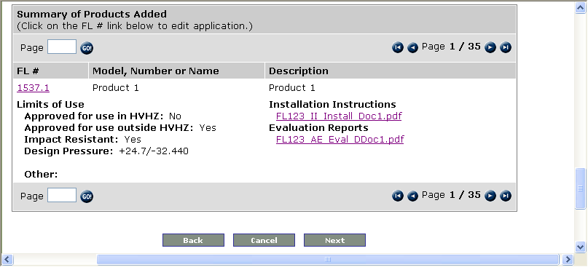

Administrative Validation Checklist, Evaluation Report from a Florida Registered Architect or a Licensed Florida Professional Engineer Method
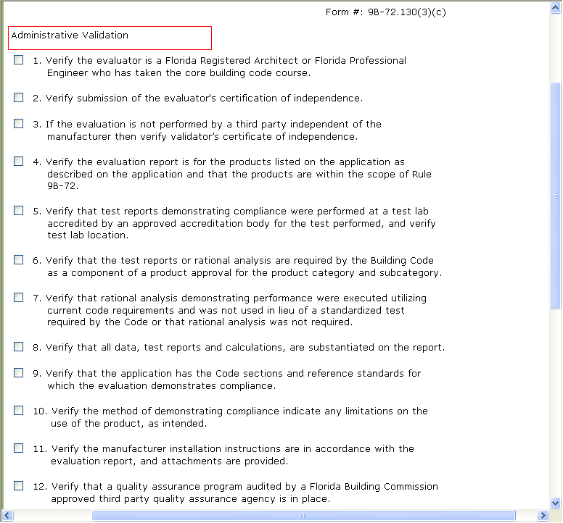
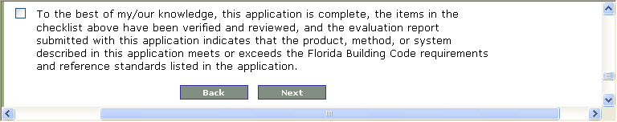

Technical Validation Checklist, Evaluation Report from a Florida Registered Architect or a Licensed Florida Professional Engineer Method
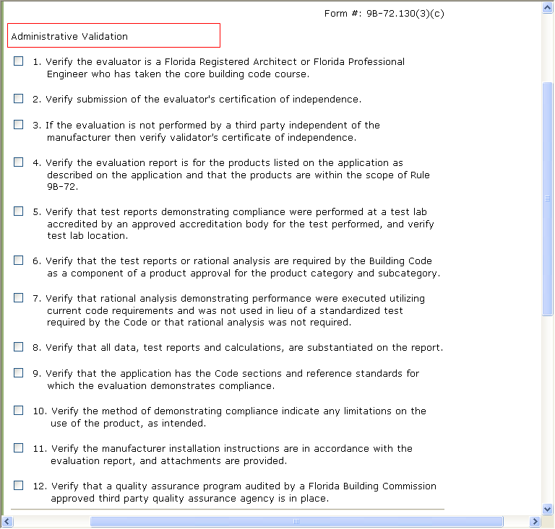
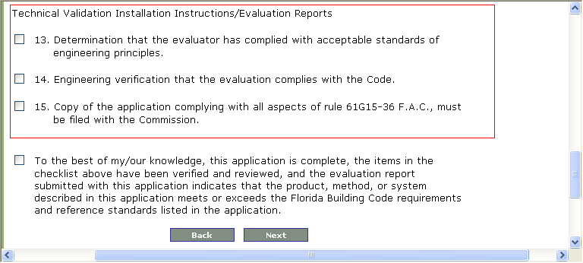
  - For the Evaluation Report from a Product Evaluation Entity Method
    - If “verification” of the Installation Instructions was done by the Evaluation Entity, there is no need to ask if an Independent Third Party created the Installation Instructions, and Administrative Validation must be done.
    - Only if the “verification” of the Installation Instructions was not done by the Evaluation Entity, ask the following:
      - On Page 3 of the Product Application, ask “Installation Instructions created by an Independent Third Party” with Yes or No answer options.
        - If the answer is Yes, Administrative Validation must be done.
        - If the answer is No, Technical Validation must be done and the following 3 checkboxes must be shown on the appropriate Validation Checklist:
          - Determination that the evaluator has complied with acceptable standards of engineering principles.
          - Engineering verification that the evaluation complies with the Code.
          - Copy of the application complying with all aspects of rule 61G15-36 F.A.C., must be filed with the Commission.
    - For the Evaluation Report from a Product Evaluation Entity Method, the Evaluation Reports are always Independent, so there is no need to ask if an Independent Third Party created the Evaluation Reports, and Administrative Validation must be done.

Submit a Product Application > Page 3, Evaluation Report from a Product Evaluation Entity Method
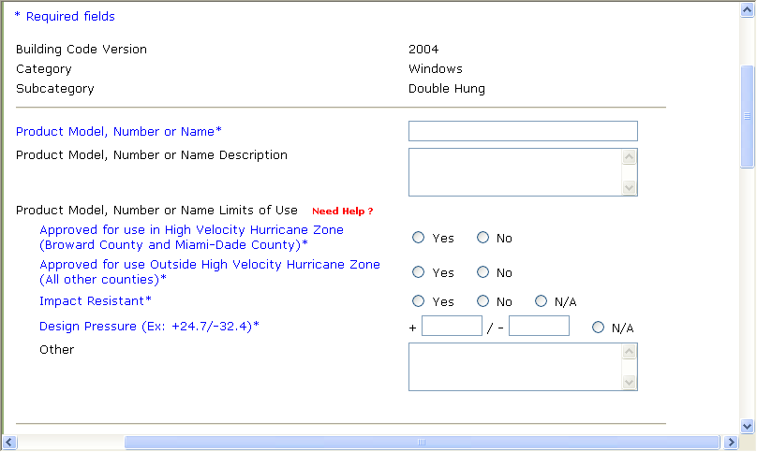
Submit a Product Application > Page 3, Evaluation Report from a Product Evaluation Entity Method (continued)
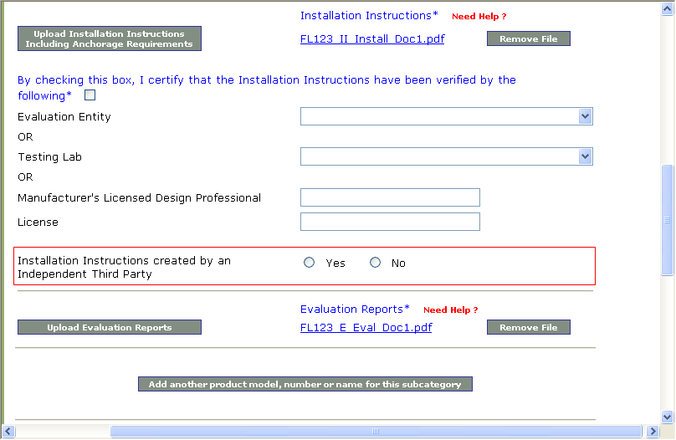
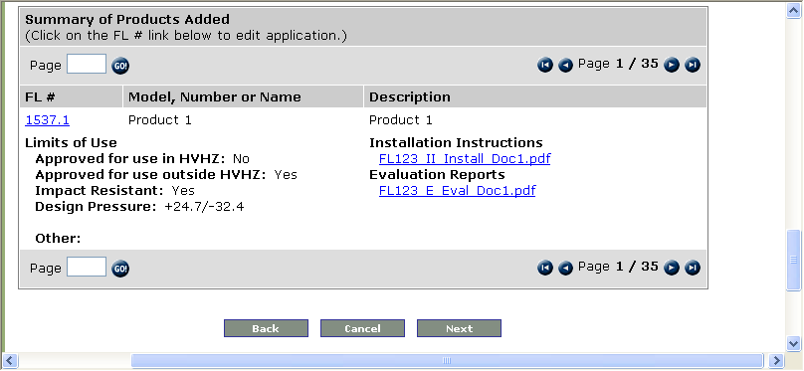

Administrative Validation Checklist, Evaluation Report from a Product Evaluation Entity Method
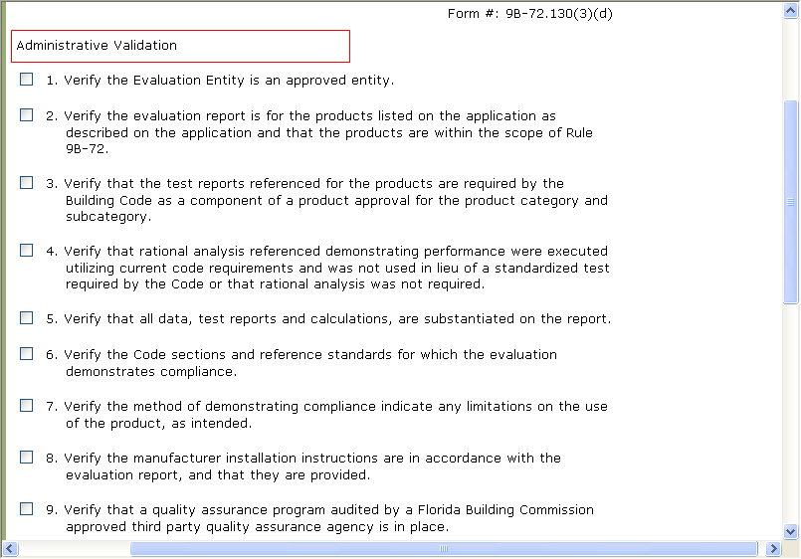
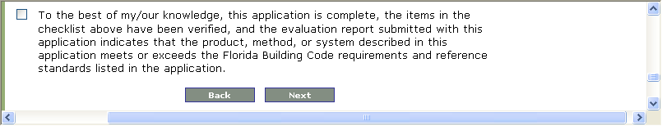

Technical Validation Checklist, Evaluation Report from a Product Evaluation Entity Method
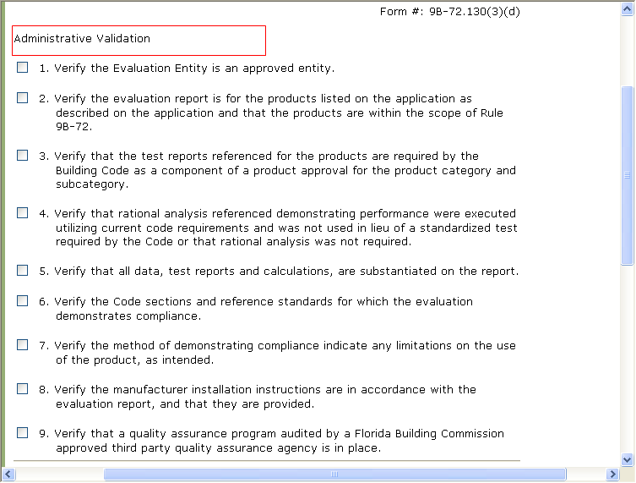
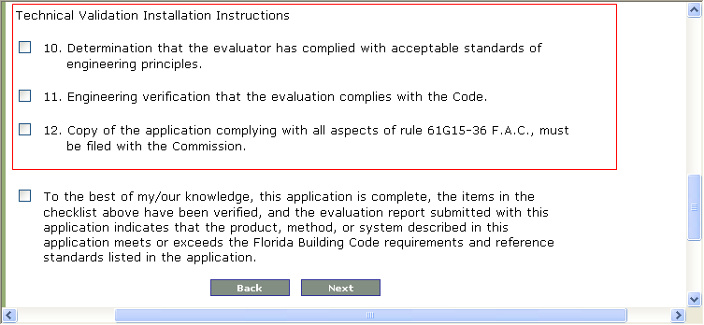

  - For the Test Report Code Compliance Method, Technical Validation is always required. Add the following 2 checkboxes to the bottom of the Test Report Method Validation Checklist:
    - Verify that the reported data demonstrates compliance with the Florida Building Code.
    - Verify that the correct test was performed.

Technical Validation Checklist, Test Report Method
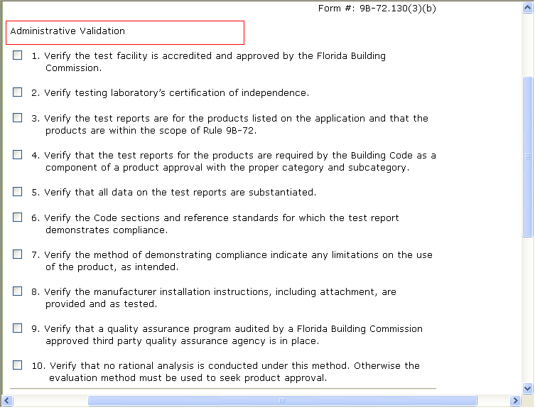
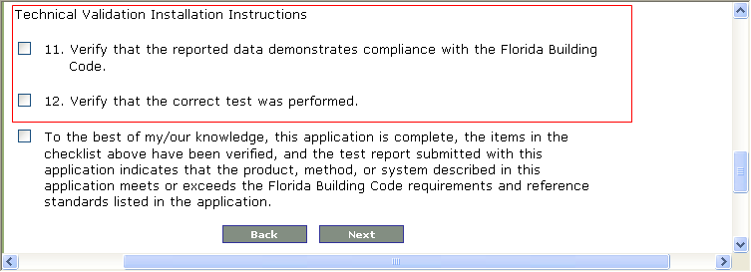
- Display different Validation Checklists per Code Compliance Method.
Estimate: 56 hours * $75/hour = $4,200

Please see Validation Checklist screen shots above in #8.

- There is currently a checkbox for “Hardcopy Received” on the Product Search for the Administrator to complete for Evaluation Report by Architect or Engineer Method applications. In addition to this checkbox, add a second checkbox for the Administrator to check if the hardcopy of the Validation Checklist was received. This checkbox would ONLY be shown on applications if the Validation Entity chosen is an Architect or Engineer (ANE). Also add text to the save success message on the Validation Checklist in this situation (similar to the Receipt page) to alert the Architect or Engineer to send in a hardcopy to A&A.
Estimate: 52 hours * $75/hour = $3,900

Administrator Manage Applications > Search All Applications Results List
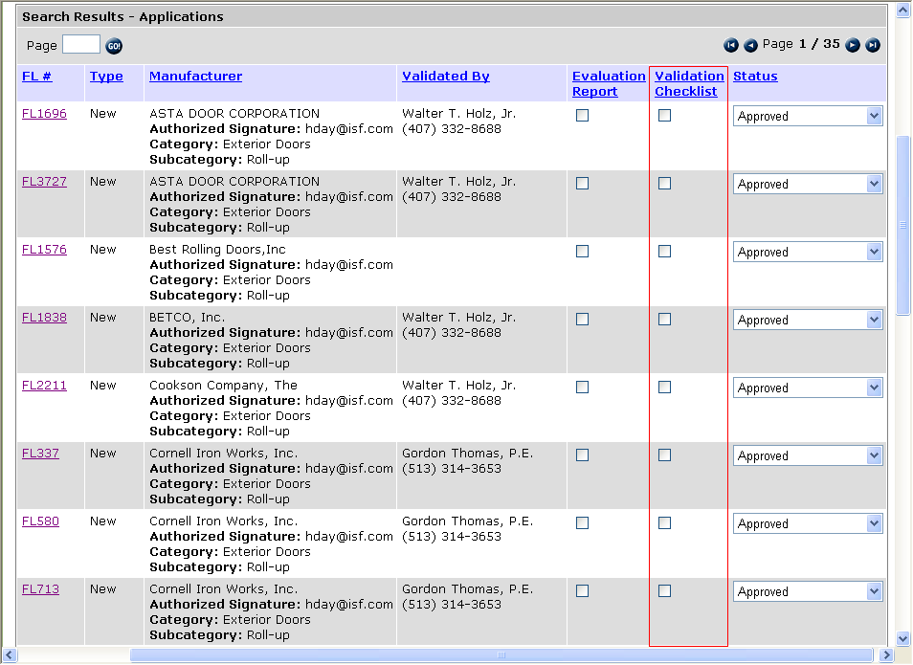

Administrator Application Detail
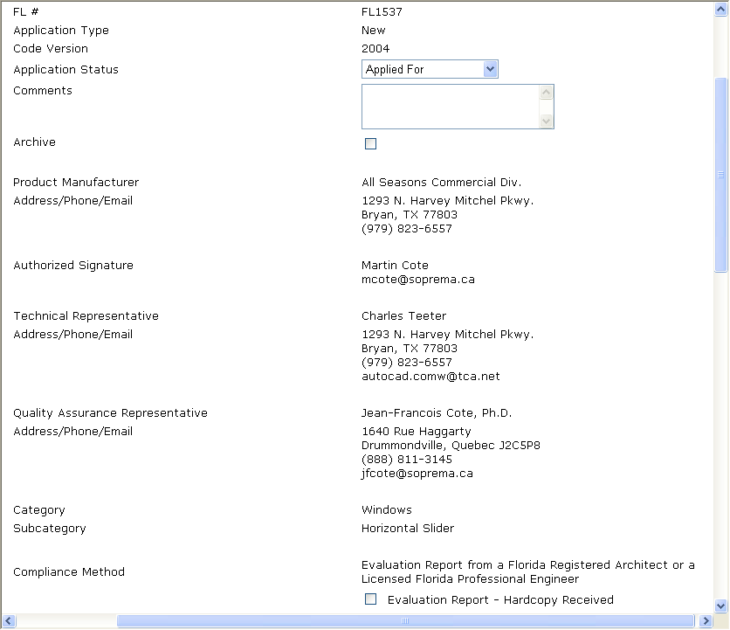
Administrator Application Detail (continued)
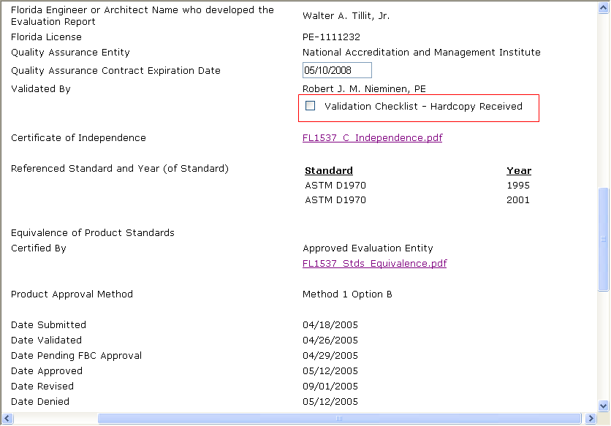
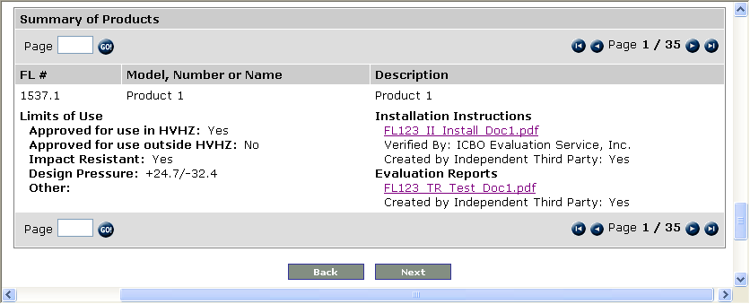

Public Application Detail
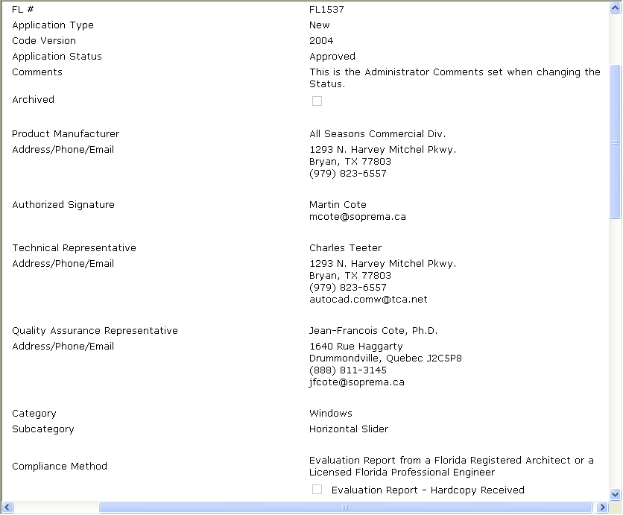

Public Application Detail (continued)
