November 17, 2009

Mr. Mo. Madani,
Manager
Codes and Standards Office
Florida Department of Community Affairs
Tallahassee, FL

email: mo.madani@dca.state.fl.us

Subject: Comments on Request for Declaratory Statement DCA09-DEC-351 to exempt Category I, II and III Sunrooms from required dwelling unit receptacle outlets in accordance with NEC 210.52

With respect, the following is offered in disagreement to exempt sunrooms of any category from complying with the requirements of NEC 210.52:

- Although the descriptions of the five AAMA/ANPE/NSA 2100 categories of sunrooms are incorporated in FBCB 2002.6 and FBCR 301.2.1.1.2 these do not include the receptacle requirements that are contained in the AAMA standard proper,

- In both of the above-mentioned cases the sunroom categorizations are incorporated in the FBC in areas that address structural and wind resistance requirements and not electrical ones. FBCR 301.2.1.1.2 includes a specific reference to structural requirements and to ASCE 7 for this purpose; FBCB 2002.6 is in the Light Metal Alloys Section, Materials Sub-section,

- The categorization of an area as nonhabitable is insufficient reason to not require receptacles. The NEC, and by reference the FBC, include several nonhabitable locations where receptacles are nonetheless required. Examples include bathrooms, hallways and laundry areas and outdoor locations such as balconies, decks and porches,

- Although Categories I, II, and III sunrooms are categorized by AAMA and the FBC as nonhabitable this does not mean that they will not be used for the purpose. In fact, habitability seems to be the central message of most advertisements for sunrooms, and

- Given that sunrooms of any Category will be used as habitable even if they are not conditioned, the absence of receptacle outlets will result in the increased use of extension cords, power strips, and may even give rise to an increase in unpermitted and uninspected electrical work, perhaps even more so when the sunroom is not conditioned. Precisely what including sunrooms in NEC 210.52 is trying to avoid.

For all the above reasons it is recommended that receptacle outlets be required for all sunrooms in accordance with NEC 210.52. All receptacles to be suitable for the environment in which they are used.

Respectfully submitted,

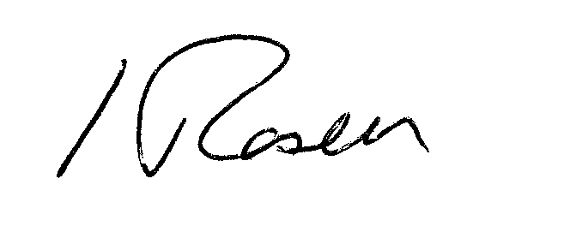

Heinz Rosen, P.E.
Director of Engineering

