Florida Building Commission

Mechanical TAC

AGENDA

February 2nd 2008 – 1.00 p.m.
Crowne Plaza Melbourne Oceanfront Hotel
2605 N AIA Highway, Melbourne FL, 1-800-980-6429 or 321-777-4100

Voting Members:
Gary Griffin – Chair
Bob Andrews, Larry Banks, Rafael Palacios, Jim Cummings, Joe Crum, Elizabeth Goll,
Dan Griffin, Scott Mollan, Donny Pitmann, Pete Quintela
Meeting Objectives:
1. Call to Order-review/approve agenda and minutes.
2. Consider Dec Statement Request:
DCA08-DEC-344 by Alvin Scolnik, National Electrical Manufacturer’s Association
3. Any new business.
4. Adjourn.

This document is available in alternate format upon request

FLORIDA BUILDING COMMISSION
Minutes

Mechanical Technical Advisory Committee

December 9, 2008
1:00 p.m.
Embassy Suites Hotel
3705 Spectrum Blvd.
Tampa, FL
813-977-7066

Voting Members:
Bob Andrews, Larry Banks, Steve Bassett, Jim Cummings, Joe Crum, Elizabeth Goll,
Dan Griffin, Gary Griffin, Scott Mollan, Donny Pitmann, Pete Quintela. Facilitated by
Jeff Blair. Staff present: Mo Madani, Betty Stevens.

1. Called to Order-reviewed and approved agenda and minutes.

2. Reviewed the request for declaratory statement DCA08-DEC-207 by Anthony C. Apfelbeck, Fire Marshal/Building Official, City of Altamonte Springs, a second time at the request of the Florida Building Commission and provide further recommendations to the Commission on its disposition.

Committee Action:
Question 1: Does the rule apply only to new construction of a new building, or does it also apply to additions or alterations as defined in the FEBC?

Answer: The rule applies to all buildings for which a permit for new construction is issued. In this case, it would apply to construction of new buildings, additions and level 3 but not level 1 or 2 alterations as defined in the FBC-Existing Building.

Question 2: If the rule applies to additions, does an addition require the complete existing structure to comply with installing CO detectors as prescribed in the rule? (hardwired and battery back up)
For example: If an attached garage or a screen enclosure is added to an existing home, are CO detectors required to be installing within the complete existing structure?

Answer: No, unless the addition meets the requirements for the Rule 9B-3.0472.

Question 3. If the rule applies to all alterations, does it require the complete existing structure to comply with installing CO detectors as prescribed in the rule? (hardwired and battery back up)
Example #1: If a new gas furnace is installed in an existing home, whereas it was electric before, are CO detectors required to be installing within the complete existing structure?
Example #2: If any type of permit is issued on the existing structure are CO detectors required to be installing within the complete existing structure?

Answer: No, it does not apply to all alterations, however it does apply to level 3 alterations.

Question 4. If the answer is yes to the questions 2 or 3 above, must hardwired CO detectors be installed with a battery backup?
Answer: No, if the addition requires a CO detector in the existing building it may be battery powered.

Question 5. Does the rule apply to repairs, as defined by the FEBC?

Answer: NO.

Question 6. Does the rule apply to a change in occupancy, as defined by the FEBC?

Answer: YES, if the change of occupancy meets the requirements or intent of Rule 9B-3.0472.

3. Reviewed the request for declaratory statement DCA08-DEC-337 by Roger Sanders, Sr. Code Consultant, Nova Engineering and Environmental, and provide a recommendation to the Commission as to whether the private provider statute allows such services to be performed for events such as an air conditioner change-out.
Question: Does the statute limit private provider services to only those inspections required under the requirements of a general building permit for an entire building or can services be provided for inspections required for specialty permits requiring only a final inspection? In other words, can private provider services be performed for an event such as an air conditioner change-out? Can services be provided for inspections required for specialty permits requiring only a final inspection?
Answer: According to s. 553.791, Florida Statutes, the law does not limit private provider services for inspections to only a general building permit for an entire building. The private provider services may include inspections required for alterations (i.e. an air-conditioner change-out) to any structure for which permitting by a local enforcement agency is required.

4. Adjourned at 3 pm.

Note: This document is available to any person requiring materials in alternate format upon request. Contact the Department of Community Affairs, 2555 Shumard Oak Boulevard, Tallahassee, Florida, 32399-2100 or call 850-487-1824

2. Consider Dec Statement Request:
DCA08-DEC-344 by Alvin Scolnik, National Electrical Manufacturer’s Association
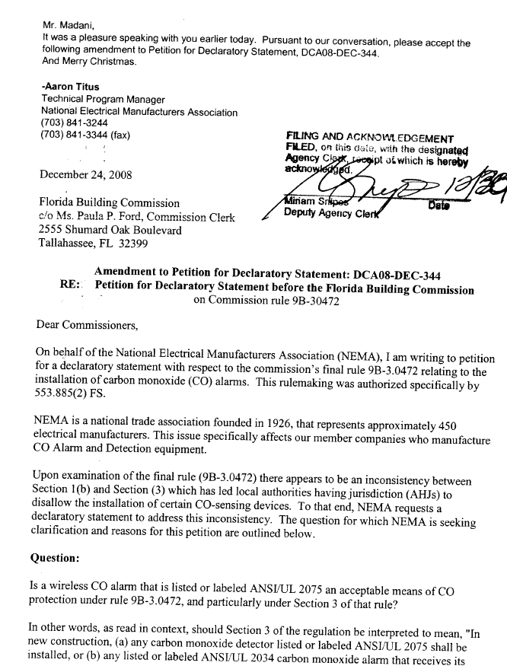
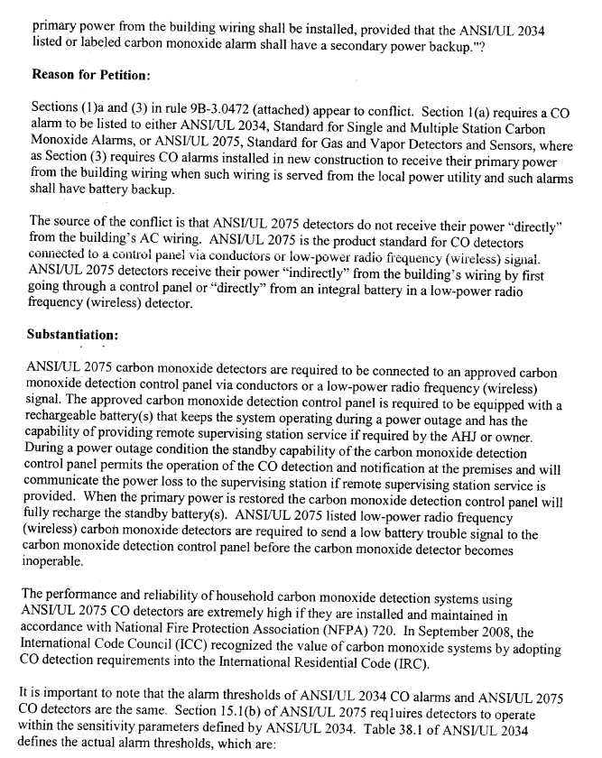
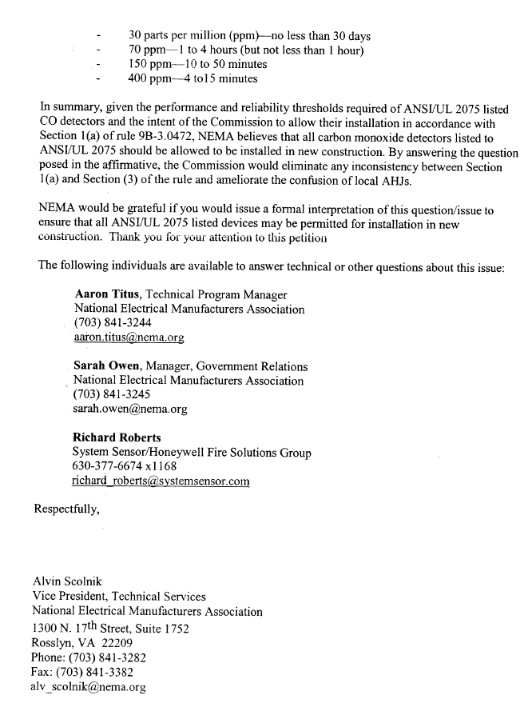
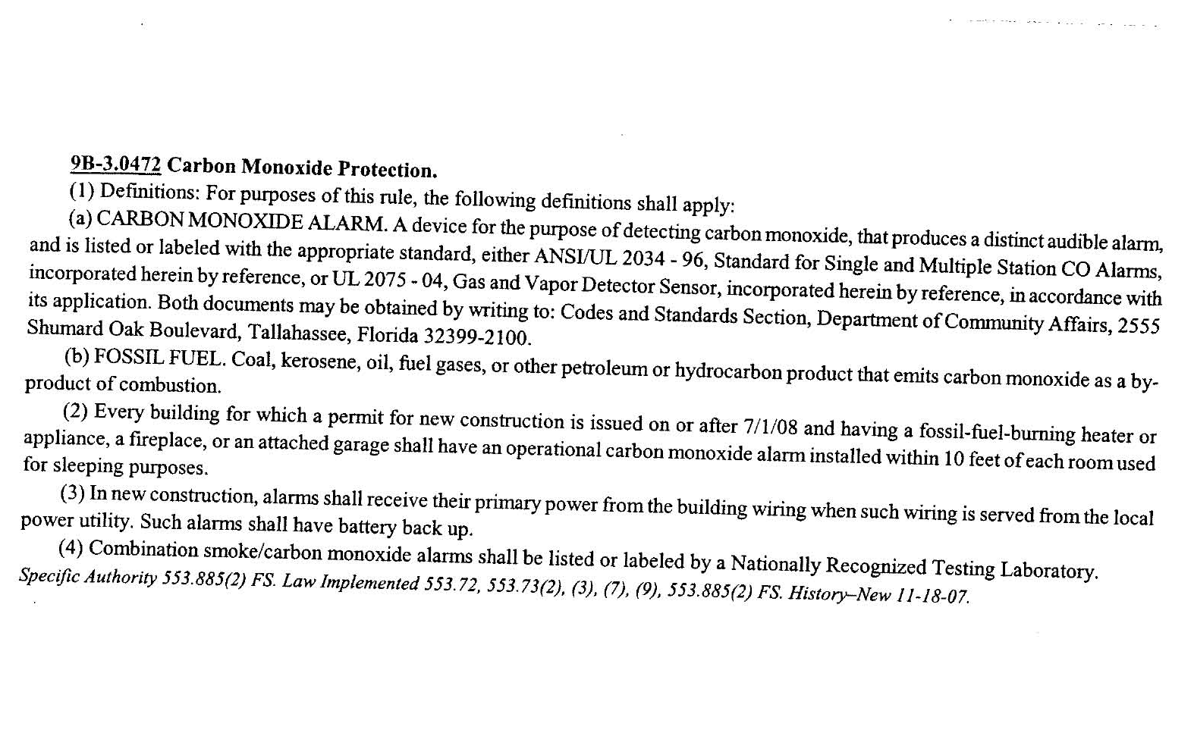
Issue: DCA08-DEC-344 by Alvin Scolnik of National Electrical Manufacturers Association. The Petitioner is requesting clarification regarding Rule 9B-3.0472 relating to the installation of Carbon Monoxide (CO) alarms.

Question: Is a wireless CO alarm that is listed or labeled ANSI/UL 2075 an acceptable means of CO protection under Rule 9B-3.047, and particularly under Section 3 of that rule? In other words, as read in context, should section 3 of the regulation be interpreted to mean, “In new construction, (a) any carbon monoxide detector listed or labeled ANSI/UL 2075 shall be installed, or (b) any listed or labeled ANSI/UL 2034 carbon monoxide alarm that receives its primary power from the building wiring shall be installed, provided that the ANSI/UL 2034 listed or labeled carbon monoxide alarm shall have a secondary power backup”?

Background:

Petitioner’s concern: Section (1) a and (3) in Rule 9B-3.0472 (attached) appear to conflict. Section 1(a) requires a CO alarm to be listed to either ANSI/UL 2034, Standard for Single and Multiple Station Carbon Monoxide Alarms, or ANSI/UL 2075 Standard for Gas and Vapor Detectors and Sensors, where as Section (3) requires CO alarms installed in new construction to receive their primary power from the building wiring when such wiring is served from the local power utility and such alarms shall have battery backup.

The source of the conflict is that ANSI/UL 2075 detectors do not receive their power “directly” from the building’s AC wiring. ANSI/UL 2075 is the product standard for CO detectors connected to a control panel via conductors or low-or low-power radio frequency (wireless) signal. ANSI/UL 2075 detectors receive their power “indirectly” from the building’s wiring by first going through a control panel or “directly” from an integral battery in a low-power radio frequency (wireless) detector.

9B-3.0472 Carbon Monoxide Protection.
(1) Definitions: For purposes of this rule, the following definitions shall apply:
(a) CARBON MONOXIDE ALARM. A device for the purpose of detecting carbon monoxide, that produces a distinct audible alarm, and is listed or labeled with the appropriate standard, either ANSI/UL 2034 - 96, Standard for Single and Multiple Station CO Alarms, or UL 2075 - 04, Gas and Vapor Detector Sensor, in accordance with its application.
(b) FOSSIL FUEL. Coal, kerosene, oil, fuel gases, or other petroleum or hydrocarbon product that emits carbon monoxide as a by-product of combustion.
(2) Every building for which a permit for new construction is issued on or after 7/1/08 and having a fossil-fuel-burning heater or appliance, a fireplace, or an attached garage shall have an operational carbon monoxide alarm installed within 10 feet of each room used for sleeping purposes.
(3) In new construction, alarms shall receive their primary power from the building wiring when such wiring is served from the local power utility. Such alarms shall have battery back up.
(4) Combination smoke/carbon monoxide alarms shall be listed or labeled by a Nationally Recognized Testing Laboratory.
Specific Authority 553.885(2) FS. Law Implemented 553.72, 553.73(2), (3), (7), (9), 553.885(2) FS. History – New

UL 2075 - Gas and Vapor Detectors and Sensors

Scope (1.1): These requirements cover toxic and combustible gas and vapor detectors and sensors intended to be portable or employed in indoor or outdoor locations in accordance with the National Electrical Code, NFPA 70. A gas detector and/or vapor detector, as covered by these requirements, consists of an assembly of electrical components coupled with a sensing means inside a chamber, or by separate components to detect toxic and/or combustible gases or vapors. The detector includes provision for the connection to a source of power and signaling circuits.

Staff recommendation:

Question: Is a wireless CO alarm that is listed or labeled ANSI/UL 2075 an acceptable means of CO protection under Rule 9B-3.047, and particularly under Section 3 of that rule?

Answer (Option #1): No. Rule 9B-3.0472(3) requires that for new construction, alarms must receive their primary power from the building wiring and thus must be hardwired.

Answer (Option #2): Yes. Alarm that is listed or labeled ANSI/UL 2075 is an acceptable means of CO protection under Rule 9B-3.072(3).

3. Any new business.

4. Adjourn.

