STRUCTURAL - Supplement
Local Technical Amendments
to the
2017 6th Edition Florida Building Code

JURISDICTION | DOCUMENT with TECHNICAL AMENDMENT | TEXT OF TECHNICAL AMENDMENT | TAC REVEW
City of Winter Park  Dies for lack of 2nd NAR | Florida Building Code, Building – Chapter 16 | Section 1609.3 Basic Ultimate wind speed. The ultimate design wind speed Vult  in miles per hour, for the development of the wind loads shall be determined by  Figures 1609 .3(1)A , 1609 .3(2)B and 1609.3(3)C . The ultimate design wind speed  Vult for use in the design of Risk Category II buildings and structures shall be  obtained from Figure 1609.3(1)A . The ultimate design wind speed Vult for use in  the design of Risk Category III and IV buildings and structures shall be obtained  from Figure 1609.3(2)B . The ultimate design wind speed Vult for use in the  design of Risk Category I buildings and structures shall be obtained from Figure  1609.3(3)C . The ultimate design wind speeds, Vult, determined by the local  jurisdiction shall be in accordance with Section 26.5.1 of ASCE 7. The exact  location of wind speed lines shall be established by local ordinance using  recognized physical landmarks such as major roads, canals, rivers and lake shores  wherever possible. For the purpose of complying with the structural requirements  related to wind loads, all buildings and structures including one and two family  dwellings shall comply with the following ultimate design wind speeds Vult:  1) Risk Category I: 130 mph  2) Risk Category II: 139.9 mph  3) Risk Category III and IV: 150 mph  As indicated in Figures 1609.3(1), (2) and (3) A, B, and C linear interpolation  between wind contour lines is permitted.  Exception: Buildings designed utilizing one of the alternate prescriptive wind  design standards permitted in the Florida Building Code.  This wind speed determination provided herein is an administrative amendment to  the Florida Building Code for the purpose of giving guidance to designers and to  provide uniformity with neighboring jurisdictions and is not a local technical  amendment or change in the published Florida Building Code wind load criteria. | Structural TAC
Leon County Building Dept  Dies for lack of 2nd NAR | Florida Building Code, Residential – Chapter R310-R311-R312 | 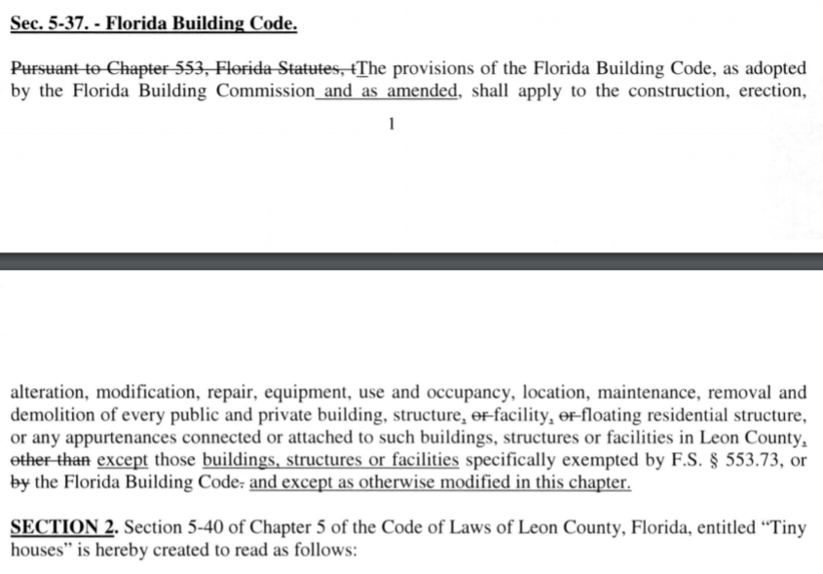  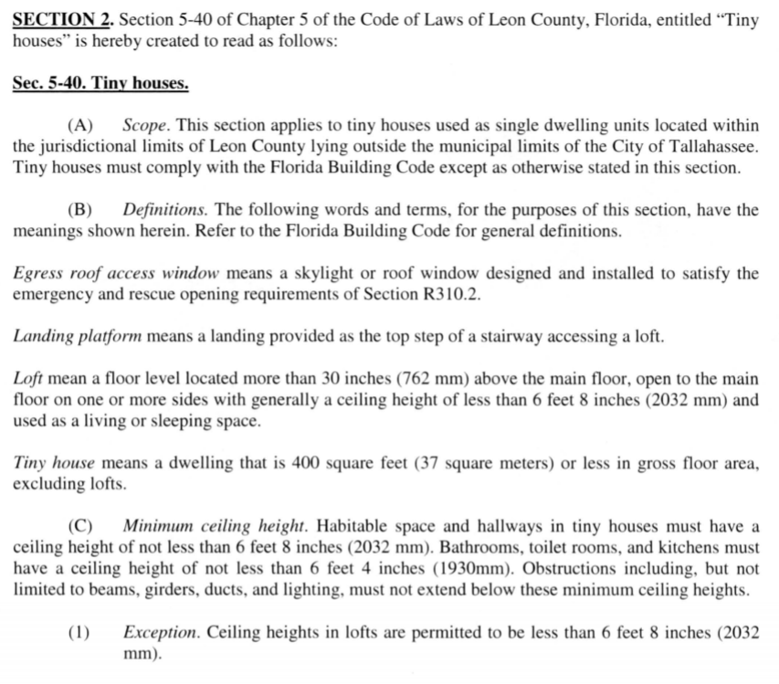  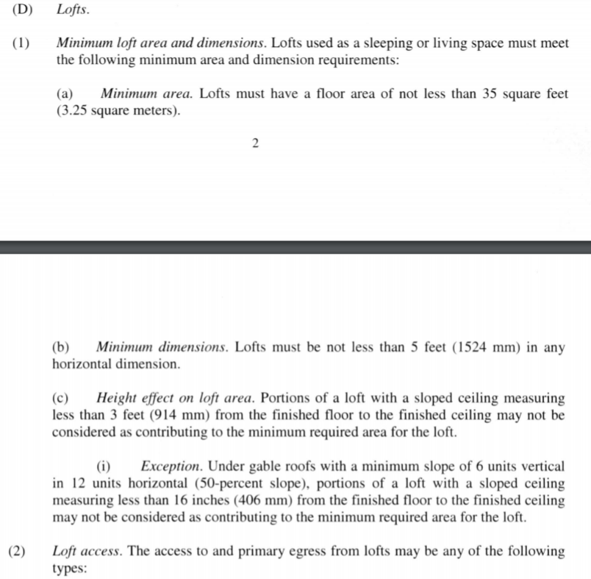  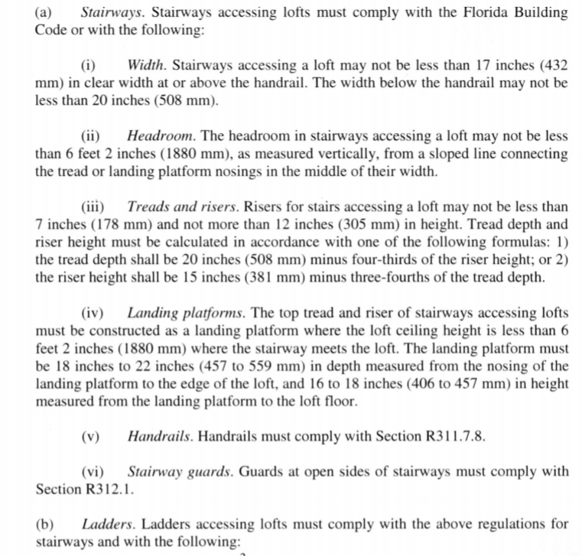  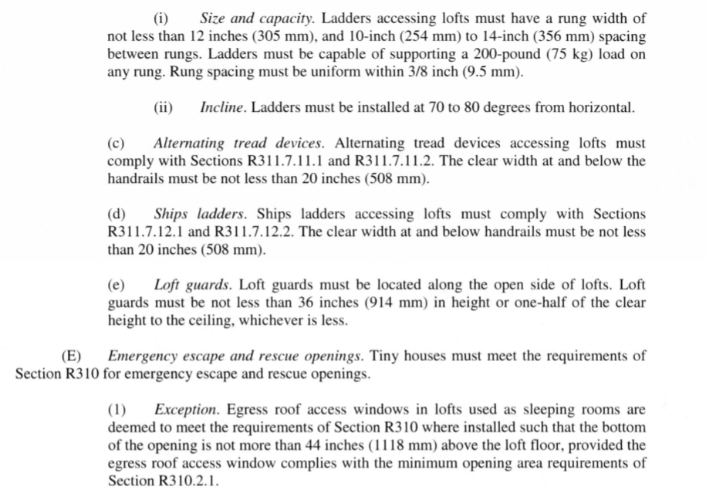 | Structural TAC and Fire TAC

