ELECTRCAL/SWIMMING - supplement
Local Technical Amendments
to the
2017 6th Edition Florida Building Code

 | DOCUMENT with TECHNICAL AMENDMENT | TEXT OF TECHNICAL AMENDMENT | TAC REVEW
County of Miami-Dade | Florida Building Code, Residential – Chapter 42  Dies for lack of 2nd NAR | 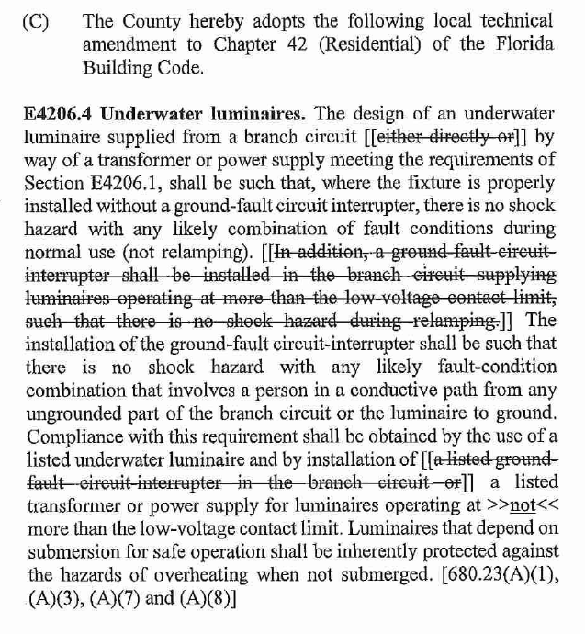  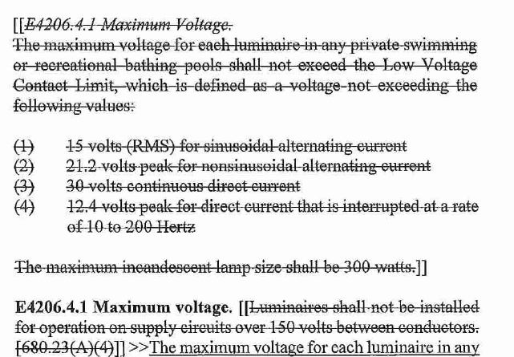  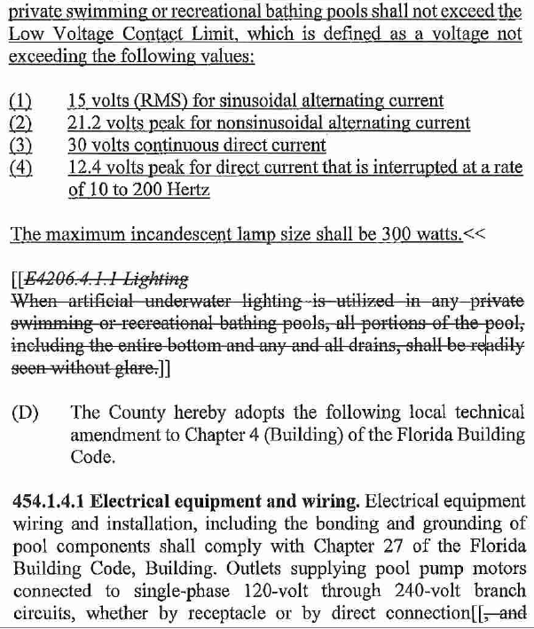  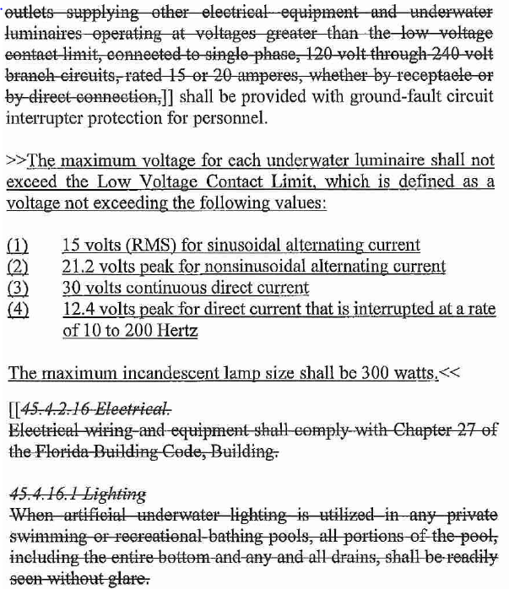  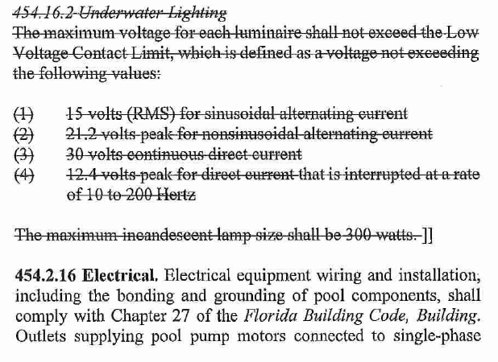  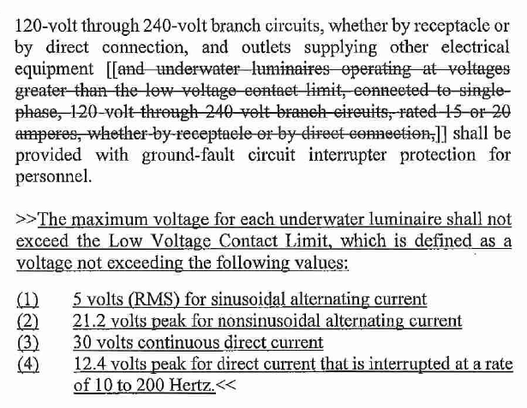 | Swimming and Electrical TACs

