**From:** Lynn Miller <LMiller@pgtindustries.com>   
**Sent:** Monday, June 12, 2023 9:39 AM  
**To:** Madani, Mo <Mo.Madani@myfloridalicense.com>  
**Cc:** Steve Urich (steve@urichengrllc.com) <steve@urichengrllc.com>  
**Subject:** RE: RE: Comments to FL#15709

|  |
| --- |
| **[NOTICE] This message comes from a system outside of DBPR. Please exercise caution when clicking on links and/or providing sensitive information. If you have concerns, please contact your Knowledge Champion or the DBPR Helpdesk.** |

Mo,

We used Section X9 to demonstrate compliance with the E1300 standard.

Sincerely,

Lynn Miller

**ANTHONY LYNN MILLER, P.E.**

CODE COMPLIANCE MANAGER

**PGT INNOVATIONS**  
3440 Technology Drive, N. Venice, FL 34275

**Office**       941.486.0100 x21142

**Cell**           941.504.6851

**Fax**           941.480.2743

[lmiller@pgtindustries.com](mailto:lmiller@pgtindustries.com) | [pgtinnovations.com](http://www.pgtinnovations.com/)

](http://pgtinnovations.com/brands)

**Venice** | Ft. Myers | Miami | Hialeah | Phoenix | Clovis | Tampa

**From:** Madani, Mo <[Mo.Madani@myfloridalicense.com](mailto:Mo.Madani@myfloridalicense.com)>   
**Sent:** Monday, June 12, 2023 9:08 AM  
**To:** Lynn Miller <[LMiller@pgtindustries.com](mailto:LMiller@pgtindustries.com)>  
**Cc:** Steve Urich ([steve@urichengrllc.com](mailto:steve@urichengrllc.com)) <[steve@urichengrllc.com](mailto:steve@urichengrllc.com)>  
**Subject:** RE: RE: Comments to FL#15709

**CAUTION:**This email originated from outside of the PGT Innovations organization. Do not click links or open attachments unless you recognize the sender and know the content is safe.

Lynn, as part of the response below, please clarify what part of the standard (specific section) was used to show compliance with the E1300.

Thanks

Mo Madani, Technical Director

Building Codes & Standards office

2601 Blair Stone Road

Tallahassee, Florida 32399

850-717-1825

**From:** Lynn Miller <[LMiller@pgtindustries.com](mailto:LMiller@pgtindustries.com)>   
**Sent:** Friday, June 9, 2023 3:58 PM  
**To:** Madani, Mo <[Mo.Madani@myfloridalicense.com](mailto:Mo.Madani@myfloridalicense.com)>  
**Cc:** Steve Urich ([steve@urichengrllc.com](mailto:steve@urichengrllc.com)) <[steve@urichengrllc.com](mailto:steve@urichengrllc.com)>  
**Subject:** RE: RE: Comments to FL#15709

|  |
| --- |
| **[NOTICE] This message comes from a system outside of DBPR. Please exercise caution when clicking on links and/or providing sensitive information. If you have concerns, please contact your Knowledge Champion or the DBPR Helpdesk.** |

Sorry, Mo.  We have discussed this matter internally and I am going to stand on my previous comments at this time.

In the email below, Yiping states that I have not provided calculations.  That is simply not the case.  I have provided calculations to my 3rd Party Technical validator as required by Section 2 (a) of 61G20-3.005 (see snippet below).

I don’t believe the product approval rule requires a non-independent evaluation entity (like me) to submit calculations to anyone other than the technical validator.  Please let me know if that is not a true statement.

Also, I must reiterate that this is NOT a safety issue as these systems have been fully tested to TAS 201/202/203 as required by the FBC for the HVHZ.  If the products did not pass these tests, I would agree that this is a public safety issue, but that is simply not the case.

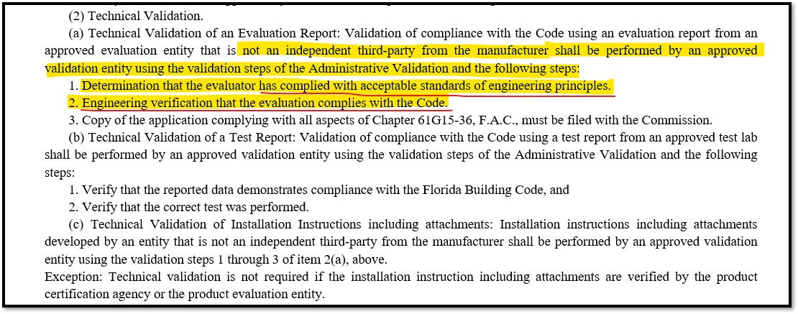

Sincerely,

Lynn Miller

**ANTHONY LYNN MILLER, P.E.**

CODE COMPLIANCE MANAGER

**PGT INNOVATIONS**  
3440 Technology Drive, N. Venice, FL 34275

**Office**   941.486.0100 x21142

**Cell**       941.504.6851

**Fax**       941.480.2743

[lmiller@pgtindustries.com](mailto:lmiller@pgtindustries.com) | [pgtinnovations.com](http://www.pgtinnovations.com/)

](http://pgtinnovations.com/brands/)

**Venice** | Ft. Myers | Miami | Hialeah | Phoenix | Clovis | Tampa | Salt Lake City

**From:** Madani, Mo <[Mo.Madani@myfloridalicense.com](mailto:Mo.Madani@myfloridalicense.com)>   
**Sent:** Friday, June 9, 2023 3:00 PM  
**To:** Lynn Miller <[LMiller@pgtindustries.com](mailto:LMiller@pgtindustries.com)>  
**Subject:** RE: RE: Comments to FL#15709

**CAUTION:**This email originated from outside of the PGT Innovations organization. Do not click links or open attachments unless you recognize the sender and know the content is safe.

Lynn, any update based on our discussion regarding this approval?

Thanks

Mo Madani, Technical Director

Building Codes & Standards office

2601 Blair Stone Road

Tallahassee, Florida 32399

850-717-1825

**From:** Lynn Miller <[LMiller@pgtindustries.com](mailto:LMiller@pgtindustries.com)>   
**Sent:** Wednesday, May 31, 2023 10:11 AM  
**To:** Madani, Mo <[Mo.Madani@myfloridalicense.com](mailto:Mo.Madani@myfloridalicense.com)>  
**Subject:** RE: RE: Comments to FL#15709

|  |
| --- |
| **[NOTICE] This message comes from a system outside of DBPR. Please exercise caution when clicking on links and/or providing sensitive information. If you have concerns, please contact your Knowledge Champion or the DBPR Helpdesk.** |

Mo,

As we discussed previously, the calculations that Yiping has provided are for Section 6 of ASTM E1300.  Since this section does not cover triple laminated glass, we opted to use an alternative method that is referenced elsewhere in the standard to perform our calculations.

I have submitted my calculations to our 3rd party technical validator who has reviewed them also.  We are in full compliance with the requirements of the product approval system and the Florida Building Code.

Unless I am misunderstanding the process, I don’t believe we are required to submit our calculations for public review.  Can you please call me so we can discuss this issue further?  These back-and-forth emails are not very productive.

Sincerely,

Lynn Miller

**ANTHONY LYNN MILLER, P.E.**

CODE COMPLIANCE MANAGER

**PGT INNOVATIONS**  
3440 Technology Drive, N. Venice, FL 34275

**Office**   941.486.0100 x21142

**Cell**       941.504.6851

**Fax**       941.480.2743

[lmiller@pgtindustries.com](mailto:lmiller@pgtindustries.com) | [pgtinnovations.com](http://www.pgtinnovations.com/)

](http://pgtinnovations.com/brands/)

**Venice** | Ft. Myers | Miami | Hialeah | Phoenix | Clovis | Tampa | Salt Lake City

**From:** Madani, Mo <[Mo.Madani@myfloridalicense.com](mailto:Mo.Madani@myfloridalicense.com)>   
**Sent:** Wednesday, May 31, 2023 9:38 AM  
**To:** Lynn Miller <[LMiller@pgtindustries.com](mailto:LMiller@pgtindustries.com)>  
**Subject:** FW: RE: Comments to FL#15709

**CAUTION:**This email originated from outside of the PGT Innovations organization. Do not click links or open attachments unless you recognize the sender and know the content is safe.

Lynn, see attached glass calculation as provided by Ms. Wang.  Please review the attached calculation and provides comments as appropriate.

Thanks

Mo Madani, Technical Director

Building Codes & Standards office

2601 Blair Stone Road

Tallahassee, Florida 32399

850-717-1825

**From:** Yiping <[Yiping@mcyengineering.com](mailto:Yiping@mcyengineering.com)>   
**Sent:** Wednesday, May 31, 2023 3:01 AM  
**To:** Madani, Mo <[Mo.Madani@myfloridalicense.com](mailto:Mo.Madani@myfloridalicense.com)>  
**Cc:** ives <[ives@mcyengineering.com](mailto:ives@mcyengineering.com)>  
**Subject:** Re: RE: Comments to FL#15709

|  |
| --- |
| **[NOTICE] This message comes from a system outside of DBPR. Please exercise caution when clicking on links and/or providing sensitive information. If you have concerns, please contact your Knowledge Champion or the DBPR Helpdesk.** |

Hi Mr. Mo,

See attached glass calculation for reference.

Any question please tell me.

Thanks and have a nice day.

Regards,

2023-05-31

Yiping Wang, P.E. (FL, NY, TX, DC, NJ, MD, VA, MS, NA)

President

MCY Engineering Inc.

12781 Miramar Parkway #301  
Miramar, FL 33027  
Tel: (305) 271-0117

Cell: (305) 588-5224  
[http://www.mcyengineering.com](http://www.mcyengineering.com/)

**From：**"Madani, Mo" <[Mo.Madani@myfloridalicense.com](mailto:Mo.Madani@myfloridalicense.com)>

**Sent：**2023-05-30 19:56

**Subject：**RE: Comments to FL#15709

**To：**"[yiping@mcyengineering.com](mailto:yiping@mcyengineering.com)"<[yiping@mcyengineering.com](mailto:yiping@mcyengineering.com)>

**Cc：**"ives"<[ives@mcyengineering.com](mailto:ives@mcyengineering.com)>

Ms. Wang, please give me a call when available.

Thanks

Mo Madani, Technical Director

Building Codes & Standards office

2601 Blair Stone Road

Tallahassee, Florida 32399

850-717-1825

**From:** Madani, Mo   
**Sent:** Friday, May 26, 2023 3:41 PM  
**To:** [yiping@mcyengineering.com](mailto:yiping@mcyengineering.com)  
**Cc:** 'ives' <[ives@mcyengineering.com](mailto:ives@mcyengineering.com)>  
**Subject:** RE: Comments to FL#15709

I have just called.  Can you please give me  a call when available.

Thanks

Mo Madani, Technical Director

Building Codes & Standards office

2601 Blair Stone Road

Tallahassee, Florida 32399

850-717-1825

**From:** [yiping@mcyengineering.com](mailto:yiping@mcyengineering.com) <[yiping@mcyengineering.com](mailto:yiping@mcyengineering.com)>   
**Sent:** Thursday, May 18, 2023 9:51 PM  
**To:** Madani, Mo <[Mo.Madani@myfloridalicense.com](mailto:Mo.Madani@myfloridalicense.com)>  
**Cc:** 'ives' <[ives@mcyengineering.com](mailto:ives@mcyengineering.com)>  
**Subject:** RE: Comments to FL#15709

|  |
| --- |
| **[NOTICE] This message comes from a system outside of DBPR. Please exercise caution when clicking on links and/or providing sensitive information. If you have concerns, please contact your Knowledge Champion or the DBPR Helpdesk.** |

Hi Mr. Mo,

Here we are discuss the safety of exterior glazing system. It is consent of public safety. Each product approval should comply with Florida Building code.  No matter he is comfortable or not, the product approval he signed has to be complied with Florida Building Code. If he cannot provide the calculations which comply with Florida Building Code, he has to revise the product approval to make them comply with Florida Building Code. Otherwise the product approval should be suspended for further investigating.

The calculations we provided are 1” solid glass which is much stronger than triple or double laminated glass. The capacity for this 1” solid glass is only 48.4 psf. It means the ¾” triple laminated glass capacity will be less than 48.4 psf. However in Florida approval FL#15709 the center glass capacity is 90 psf, which is too much off from the glass capacity. It is dangerous for this size glass if the hurricane comes.

I insist that the Florida Building Code Commission to review this Florida Approval FL#15709 and make it corrected.

Regards,

Yiping Wang, P.E. (FL, NY, TX, DC, NJ, MD, VA, MS, NA)

President

MCY Engineering Inc.

**\*Please note that we have moved offices. Our new address is listed here.**

12781 Miramar Parkway #301

Miramar, FL. 33027

Tel.: (786) 360-2786

Cell: (305) 588-5224

[http://www.mcyengineering.com](http://www.mcyengineering.com/)

**From:** Madani, Mo <[Mo.Madani@myfloridalicense.com](mailto:Mo.Madani@myfloridalicense.com)>   
**Sent:** Thursday, May 18, 2023 1:17 PM  
**To:** Yiping <[Yiping@mcyengineering.com](mailto:Yiping@mcyengineering.com)>  
**Subject:** FW: Comments to FL#15709

Yiping, please see response below.

Thanks

Mo Madani, Technical Director

Building Codes & Standards office

2601 Blair Stone Road

Tallahassee, Florida 32399

850-717-1825

**From:** Lynn Miller <[LMiller@pgtindustries.com](mailto:LMiller@pgtindustries.com)>   
**Sent:** Thursday, May 18, 2023 12:13 PM  
**To:** Madani, Mo <[Mo.Madani@myfloridalicense.com](mailto:Mo.Madani@myfloridalicense.com)>  
**Subject:** RE: Comments to FL#15709

|  |
| --- |
| **[NOTICE] This message comes from a system outside of DBPR. Please exercise caution when clicking on links and/or providing sensitive information. If you have concerns, please contact your Knowledge Champion or the DBPR Helpdesk.** |

Mo,

As we discussed on the phone, I am not comfortable discussing specifically how to perform our E1300 calculations with one of our biggest competitors.

I will state that the triple laminated glass that is referenced in this approval is not covered in the non-factored load charts of ASTM E1300 which are the basis of the attached calculations.  ASTM E1300 does include other calculation methods that can be used to perform calculations for this type of glass make-up.

Sincerely,

Lynn Miller

**ANTHONY LYNN MILLER, P.E.**

CODE COMPLIANCE MANAGER

**PGT INNOVATIONS**  
3440 Technology Drive, N. Venice, FL 34275

**Office**   941.486.0100 x21142

**Cell**       941.504.6851

**Fax**       941.480.2743

[lmiller@pgtindustries.com](mailto:lmiller@pgtindustries.com) | [pgtinnovations.com](http://www.pgtinnovations.com/)

](http://pgtinnovations.com/brands/)

**Venice** | Ft. Myers | Miami | Hialeah | Phoenix | Clovis | Tampa | Salt Lake City

**From:** Madani, Mo <[Mo.Madani@myfloridalicense.com](mailto:Mo.Madani@myfloridalicense.com)>   
**Sent:** Tuesday, May 16, 2023 8:54 AM  
**To:** Lynn Miller <[LMiller@pgtindustries.com](mailto:LMiller@pgtindustries.com)>  
**Subject:** FW: Comments to FL#15709

**CAUTION:**This email originated from outside of the PGT Innovations organization. Do not click links or open attachments unless you recognize the sender and know the content is safe.

Lynn, please see comments below regarding FL 15709.  Please provide response to the comments as appropriate.

Thanks Lynn

Mo Madani, Technical Director

Building Codes & Standards office

2601 Blair Stone Road

Tallahassee, Florida 32399

850-717-1825

**From:** [yiping@mcyengineering.com](mailto:yiping@mcyengineering.com) <[yiping@mcyengineering.com](mailto:yiping@mcyengineering.com)>   
**Sent:** Monday, May 15, 2023 8:49 AM  
**To:** Madani, Mo <[Mo.Madani@myfloridalicense.com](mailto:Mo.Madani@myfloridalicense.com)>  
**Cc:** 'ives' <[ives@mcyengineering.com](mailto:ives@mcyengineering.com)>; 'Samir Sabagh' <[ssabagh@energiasolarsa.com](mailto:ssabagh@energiasolarsa.com)>  
**Subject:** Comments to FL#15709

|  |
| --- |
| **[NOTICE] This message comes from a system outside of DBPR. Please exercise caution when clicking on links and/or providing sensitive information. If you have concerns, please contact your Knowledge Champion or the DBPR Helpdesk.** |

Hi Mo, Good morning!

I have following comments regarding Florida Approval FL#15709.

1. As per Florida Building Code 2020 Section 2402.1 the window wall/Curtain wall system the load resistance of  glass under uniform load shall be determined in accordance with ASTM E1300.

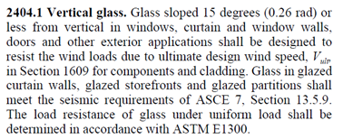

1. The window wall system in HVHZ not only should pass TAS 201, 202 & 203 but also the glass should also be in compliance with ASTM E1300.
2. In current Florida approval FL 15709 the center glass panel, in RED Cloud shown in elevation below, are supported by top and bottom only. On each side the glass, the glass edges are not supported since there is no mullion at each side. See detail E: 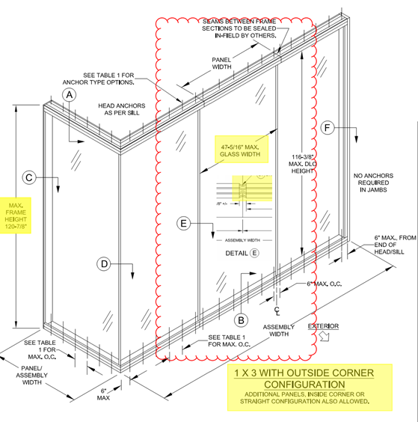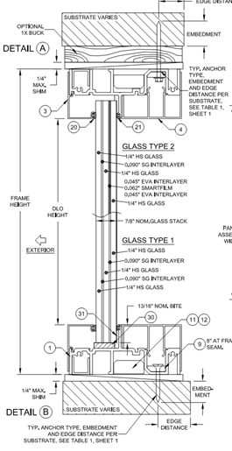
3. The glass used in FL #15709 is triple laminated glass - 1/4"HS + 0.090"SG + 1/4"HS + 0.090"SG + 1/4"HS, the total glass thickness is 0.837”, the glass capacity as per FL#15709 is 90 psf

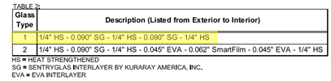

cid:image011.png@01D99D10.AE0E2360

1. As per ASTM E1300 the 1” HS, the total glass thickness is 0.969”, the glass capacity is 48.4 psf (see attached). Even though the ASTM E1300 did not have detailed instruction for triple laminated glass calculations, the 1” solid HS glass is much stronger than ¾” triple laminated glass. The glass capacity for 1” HS glass is only 48.4 psf which is much less than 90 psf which specified in FL#15709 for ¾” laminated glass. The calculations for 1” solid HS glass is attached.

From all above we can see that the center glass capacity in Florida approval FL#15709 are not meet the ASTM E1300 and Florida Building Code requirements. I strongly recommend that Florida Building Code Commission review this Florida Approval FL#15709 and have it corrected.

Thank you.

Regards,

Yiping Wang, P.E. (FL, NY, TX, DC, NJ, MD, VA, MS, NA)

President

MCY Engineering Inc.

12781 Miramar Parkway #301

Miramar, FL. 33027

Tel.: (786) 360-2786

Cell: (305) 588-5224

[http://www.mcyengineering.com](http://www.mcyengineering.com/)

**From:** Madani, Mo   
**Sent:** Thursday, May 11, 2023 8:15 AM  
**To:** ives <[ives@mcyengineering.com](mailto:ives@mcyengineering.com)>  
**Subject:** RE: RE: A question to FL#15709

Ives, the following is the response from PGT:

I am very familiar with the E1300 standard as I sit on the ASTM E06.52 committee and have been directly involved with the development of that standard since 2010.

The E1300 standard contains multiple methods to achieve compliance and we have ensured that the glass for the product referenced below is in full compliance with this standard.

These products have also been tested in full compliance with the TAS 201, 202, and 203 standards to 1.5 times the design load with structural loads held for 30 seconds so I am confident that this product is fully compliant with the HVHZ requirements of the Florida Building Code.

**ANTHONY LYNN MILLER, P.E.**

CODE COMPLIANCE MANAGER

**PGT INNOVATIONS**  
3440 Technology Drive, N. Venice, FL 34275

**Office**   941.486.0100 x21142

**Cell**       941.504.6851

**Fax**       941.480.2743

Thanks

Mo Madani, Technical Director

Building Codes & Standards office

2601 Blair Stone Road

Tallahassee, Florida 32399

850-717-1825

**From:** ives <[ives@mcyengineering.com](mailto:ives@mcyengineering.com)>   
**Sent:** Wednesday, May 10, 2023 8:49 PM  
**To:** Madani, Mo <[Mo.Madani@myfloridalicense.com](mailto:Mo.Madani@myfloridalicense.com)>  
**Cc:** Yiping Wang <[yiping@mcyengineering.com](mailto:yiping@mcyengineering.com)>  
**Subject:** Re: RE: A question to FL#15709

|  |
| --- |
| **[NOTICE] This message comes from a system outside of DBPR. Please exercise caution when clicking on links and/or providing sensitive information. If you have concerns, please contact your Knowledge Champion or the DBPR Helpdesk.** |

Hi Mo,

Sorry to miss the call, it is a little late for you now, Yiping will call you back tomorrow morning.

Thanks.

Regards,

2023-05-10

Ives

Vice President

MCY Engineering Inc.

12781 Miramar Parkway #301  
Miramar, FL 33027  
Tel: (305) 271-0117

Cell: (305) 588-5224  
[http://www.mcyengineering.com](http://www.mcyengineering.com/)

**From：**"Madani, Mo" <[Mo.Madani@myfloridalicense.com](mailto:Mo.Madani@myfloridalicense.com)>

**Sent：**2023-05-11 04:37

**Subject：**RE: A question to FL#15709

**To：**"ives"<[ives@mcyengineering.com](mailto:ives@mcyengineering.com)>

**Cc：**

I have just called and I was unable to leave a message.  Please call me when available.

Thanks

Mo Madani, Technical Director

Building Codes & Standards office

2601 Blair Stone Road

Tallahassee, Florida 32399

850-717-1825

**From:** ives <[ives@mcyengineering.com](mailto:ives@mcyengineering.com)>   
**Sent:** Tuesday, May 9, 2023 2:31 AM  
**To:** Madani, Mo <[Mo.Madani@myfloridalicense.com](mailto:Mo.Madani@myfloridalicense.com)>  
**Cc:** Yiping Wang <[yiping@mcyengineering.com](mailto:yiping@mcyengineering.com)>; Samir Sabagh <[ssabagh@energiasolarsa.com](mailto:ssabagh@energiasolarsa.com)>  
**Subject:** A question to FL#15709

|  |
| --- |
| **[NOTICE] This message comes from a system outside of DBPR. Please exercise caution when clicking on links and/or providing sensitive information. If you have concerns, please contact your Knowledge Champion or the DBPR Helpdesk.** |

Hello Mo,

This is Ives from MCY, hope you and your family goes very well.

We have a question to FL#15709, please see attached installation drawing and evaluation report from website.

Our client now has a similar product to develop, they wanted to have the same or near glass size and design pressure than FL#15709.

Based on Florida Building Code Chapter 24, this type of glass shall be pass the calculation as per ASTM E1300, and we did a calculation on the glass size and design pressure shown in this Florida Approval. But we found that the glass (1/4"HS + 0.090"SG + 1/4"HS + 0.090"SG + 1/4"HS) with a size of 48" wide X 120" high can not pass +/-90psf wind load.

Please see attached glass calculation based on ASTM E1300, we took a 3/4" overall thickness glass as an example, this single piece of glass shall be almost same as the glass configuration in FL#15709. Additional panels can be added which is mentioned in this Florida Approval, so the glass shall be considered to be supported by top and bottom. The glass strength result is overstressed by 255%, although the glass is not completely the same, but there should not be a so big difference between them, this is very confused.

Could you please help do some research on this? Did we misunderstand anything for the glass code?

Thanks and have a nice day.

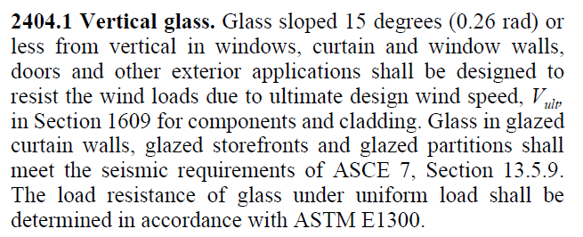

Regards,

2023-05-09

Ives

Vice President

MCY Engineering Inc.

12781 Miramar Parkway #301  
Miramar, FL 33027  
Tel: (305) 271-0117

Cell: (305) 588-5224  
[http://www.mcyengineering.com](http://www.mcyengineering.com/)